**Studying Access to Healthcare Patterns using Medicare Health Insurance Data**

Nicole Rachel Koshy1, Prudhvi Raj Terli1, Mothi Gowtham Ashok Kumar1, Sony Priya Surapaneni1, [Vineela Deepthi Oguri](https://iu.instructure.com/groups/824427/users/6707564)1, [Divya Gottimukkula](https://iu.instructure.com/groups/824427/users/6691937)1, Santosh Bokka1

1Indiana University, Indianapolis, IN 46202, USA

[nickoshy@iu.edu](mailto:nickoshy@iu.edu), [pterli@iu.edu](mailto:pterli@iu.edu), [moashok@iu.edu](mailto:moashok@iu.edu), [sonsurap@iu.edu](mailto:sonsurap@iu.edu), voguri@iu.edu, digott@iu.edu, [sanbokk@iu.edu](mailto:sanbokk@iu.edu)

**Abstract.** This project aims to determine if there is a difference in the access and utilization of Medicare health insurance services at various geographic, demographic, and epidemiological levels. We use inpatient and outpatient data from 2018-2020 to determine differences in access to services before and during the COVID pandemic. Since Medicare is most commonly availed by older citizens, we also use Post-Acute care and Hospice data to study differences in access to services based on gender, chronic conditions, duration of utilization, and Medicare payments. This data can be used to understand the most common services availed by older patients and to examine if the differences in cost of care and access can be attributed to a few key factors.

**Keywords:** Medicare • CMS • inpatient • outpatient • post-acute care • hospice • skilled nursing facility • inpatient rehabilitation facility • long term care facility • clustering • healthcare • health insurance • data analysis • data visualization • SQL • python.

1. **Project Scope**
   1. **Introduction**

Medicare is a federally financed health insurance program for US citizens over the age of 65 years and younger individuals with disabilities or end-stage renal disease (Mues 20171). Since almost all individuals who are enrolled in Medicare do not leave the program until they die, the data captured from hospitals participating in the program provides a wealth of information about the key features of the health services being provided to the elderly population, the most common diseases afflicting the elderly, the demographic dynamics of the people who have access and benefit from this program.

Some examples of this include how Medicare data was used to determine that hospitals being given incentives to reduce patient readmissions fared better than hospitals that were penalized when they failed to do so (Hoffman 20202). Another study concluded that reducing a certain subset of low value services that offer negligible clinical benefit to patients but cumulatively account for significant spending in the program would serve as an effective cost saving measure (Reid 20213).

Medicare provides a variety of different coverages that are split into 4 main parts - A to D. Part A covers Hospital Insurance which covers inpatient (IPS) care, skilled nursing facilities, hospice, and home health care. Part B covers Medical Insurance, including outpatient (OPD) services, home health, medical equipment, and preventive services. Part D provides prescription coverage while Part C, which has been added in recent years, refers to the Medicare Advantage plans that offers coverage from private institutions as an alternative to the original Medicare plans4.

Post-Acute Care (PAC) and Hospice Services, which is covered under parts A and B, are of 5 major types:

1. Skilled Nursing Facilities (SNF): In-patient treatment and rehabilitation facility with trained medical professionals that include licensed nurses, physical and occupational therapists among others 5.
2. Home Health (HH) Services: Health care services that can be provided at a patient's home for an illness or injury 6.
3. Hospice (HOS) care: Services that focus on end-of-life care which can be provided at home or in facilities that provide care, comfort and quality of life to terminal patients7.
4. Inpatient Rehabilitation Facility (IRF): Independent rehabilitation centers in acute care hospitals for patients that require round the clock nursing care 8.
5. Long Term Care (LTC) Facility: Facilities that provide various types of services required for patients who are unable to live independently 9.

For the purposes of this project, we will be using Inpatient, outpatient, post-acute care and hospice service provider data available from the Center for Medicare and Medicaid services (CMS) to study access to healthcare services across the US as well as within the state of Indiana.

* 1. **Aim**

Our aim is to utilize this data to elucidate the type of facilities available, costs associated with services provided, and the patterns of healthcare services available for some of the commonly treated indications through this program. To study this we asked the following questions:

1. Has there been a change in the inpatient and outpatient procedures patients access pre-pandemic (2018-2019) compared to during the pandemic (2020) which is discernable at various geographic levels (City, State)?
2. What is the difference in cost for the most frequently used procedures across cities within a State or between neighboring states?
3. Is there a disparity in the availability of inpatient and outpatient procedures across various geographic levels (such as Transplants, Hip and Knee Replacements)?
4. Can we use Hospital rating criteria and access to care for various demographic populations (percentage of people able to access services by ethnicity, medical conditions, total visits and discharges) to segregate facilities of a specific type (Inpatient Rehabilitation Facilities (IRF), Skilled Nursing Facilities (SNF), Home Health (HH), Hospice (HOS) and Long-Term Care (LTC) hospitals) into distinct clusters?

Based on our research questions, our hypothesis is below:

**To study the distribution of services across various geographic and demographic levels**

**Null Hypothesis:**

* There is no difference in the types of services available to patients across different geographic levels (cities, states, and across different states).
* There is no difference in the types of services available to patients across different demographic levels (based on ethnicity, and disease conditions).

**Alternative Hypothesis:**

* There is a discernible difference in the types of services available to patients across different geographic levels (cities, states, across different states).
* There is a discernible difference in the types of services available to patients across different demographic levels (based on ethnicity, and disease conditions).

**For Clustering Analysis**

**Null Hypothesis:** There are no subsets in the data that are more like each other than the rest of the data i.e., Hospital facilities cannot be segregated based on overall ratings, demographic access to care data, and hospital encounter criteria.

**Alternative Hypothesis:** There are subsets in the data that have higher similarity to each other than the rest of the data i.e., Hospital facilities can be segregated based on overall ratings, demographic access to care data, and hospital encounter criteria.

* 1. **Purpose**

In the past, Medicare data has been used to build models to predict clinical outcomes (MacKay 202111), primary care practices (Wingrove 202010).

The purpose of our study is to use Medicare data to study the distribution of patient services across cities and areas in a single state (example: Indiana) or a larger geographical area. The results generated from this study could be used to understand the average cost of care for major classes of diseases, the accessibility of facilities within an area that provide the most common services required by patients enrolled in the Medicare program.

1. **Methodology**
   1. **Steps of the Project**

The focus of our project involves examining distribution of different types of medical facilities across the US to determine if there is a difference in the healthcare facilities available to citizens based on geography, demographics and chronic conditions. The tools used are Python Jupyter notebook and phpMyAdmin.

The 4 main stages of our project are:

1. Data Collection

2. Data Extraction and Storage

3. Data Analysis

4. Data Visualization

* 1. **Original Team Members and Responsibilities**

Our team consists of people from medical, biotechnology and engineering backgrounds. Our credentials and original set of responsibilities are listed below in Table 1.

|  |  |  |
| --- | --- | --- |
| **TEAM MEMBER** | **BACKGROUND** | **RESPONSIBILITIES** |
| Sony Priya Surapaneni | Bachelor of Dental surgery, New to SQL and Python | Data Understanding |
| [Divya Gottimukkula](https://iu.instructure.com/groups/824427/users/6691937) | Bachelor of Pharmacy, New to SQL and Python | Data Extraction |
| Santosh Bokka | Bachelor of Dental surgery, New to SQL and Python | Data Cleaning |
| [Vineela Deepthi Oguri](https://iu.instructure.com/groups/824427/users/6707564) | Bachelor of pharmacy, Master's in pharmacy, New to SQL and Python | Exploratory Data Analysis |
| Prudhvi Raj Terli | Bachelor of Dental surgery, New to SQL and Python | Exploratory Data Analysis |
| Mothi Gowtham Ashok Kumar | Bachelor of Engineering, Experienced in SQL, Tableau, and beginner in Python | Descriptive Statistics, Hypothesis Testing |
| Nicole Koshy | MSc Bioinformatics, MS Biotech with experience in SQL and beginner level in Python and R | Visualization, Model Design, and Evaluation, Project Proposal & Report |

**Table 1:** Original Responsibilities of Team Members for This Project

* 1. **Actual Contributions from Individual Team Members**

Since our team contained several Health Informatics students who are new to SQL and Python, they focused on understanding the data and finding patterns in the data that are relevant to our project while others in our group focused on the SQL and python processing of the data. Below is the updated table of our responsibilities.

|  |  |
| --- | --- |
| **TEAM MEMBER** | **RESPONSIBILITIES** |
| Sony Priya Surapaneni | Data Understanding, Exploratory Data Analysis, Project Presentation, Inferring conclusions, Proof reading report |
| [Divya Gottimukkula](https://iu.instructure.com/groups/824427/users/6691937) | Data Understanding, Exploratory Data Analysis, Project Presentation, Proof reading report |
| Santosh Bokka | Data Understanding, Exploratory Data Analysis, Project Presentation |
| [Vineela Deepthi Oguri](https://iu.instructure.com/groups/824427/users/6707564) | Data Understanding, Exploratory Data Analysis, Project Presentation |
| Prudhvi Raj Terli | Data Extraction, SQL Data Analysis, Exploratory Data Analysis, Inferring conclusions, Proof reading report |
| Mothi Gowtham Ashok Kumar | Data Extraction, Exploratory Data Analysis, Python Visualization, Proof reading report |
| Nicole Koshy | Cleaning, SQL Analysis, Python Visualization, Hypothesis Testing, Model Design, and Evaluation, Project Proposal & Report |

**Table 2:** Revised Responsibilities of Team Members for this Project

* 1. **Project Challenges**

While most of us in the group have some background in the healthcare domain, one challenge many members faced was understanding the datasets since we chose to use multiple datasets for our analysis. This significantly increased the time needed to come up with relevant research questions.

Cleaning the data was also a challenge since one of our datasets had 130 columns of which a subset of 60-80 were relevant for each subset in which columns had to be cleaned individually to replace suppressed data which took us almost 2 full days to complete.

Finally, a major hurdle we faced was running queries in SQL and Python. Even though the capacity of our group database was eventually increased, due to the large sizes of our datasets and multiple teams working on the same limited infrastructure, it was very common for SQL queries to require a long time to run, python notebooks not getting saved with updates due to frequent loss of connection to the server when using VPN for remote access. These issues have persisted to the very last days of our project and have required us to redo changes in codes more than once before they could be successfully saved.

1. **Data Collection**

The following datasets available at The Centers for Medicare and Medicaid Services were used for this study. For normalization by population, 2020 data from the US Census Bureau was taken:

1. **Medicare Inpatient Hospitals** – by Provider and Service – 2018 to 2020

https://data.cms.gov/provider-summary-by-type-of-service/medicare-inpatient-hospitals/medicare-inpatient-hospitals-by-provider-and-service

1. **Medicare Outpatient Hospitals** – by Provider and Service – 2018 to 2020

https://data.cms.gov/provider-summary-by-type-of-service/medicare-outpatient-hospitals/medicare-outpatient-hospitals-by-provider-and-service

1. **Medicare Post-Acute Care and Hospice** – by Geography & Provider

https://data.cms.gov/provider-summary-by-type-of-service/medicare-post-acute-care-and-hospice-by-geography-provider

1. **US Census Bureau Data** – Statewide and City level

https://www.census.gov/data/tables/time-series/demo/popest/2020s-total-cities-and-towns.html#ds

The dataset consists of the following raw data files:

1. [MUP_IHP_RY21_P02_V10_DY18_PrvSvc.csv](https://courserv01.soic.iupui.edu/jupyterhub/user/nickoshy/edit/MUP_IHP_RY21_P02_V10_DY18_PrvSvc.csv)
2. [MUP_IHP_RY21_P02_V10_DY19_PrvSvc_0.csv](https://courserv01.soic.iupui.edu/jupyterhub/user/nickoshy/edit/MUP_IHP_RY21_P02_V10_DY19_PrvSvc_0.csv)
3. [MUP_IHP_RY22_P02_V10_Dy20_Geo.csv](https://courserv01.soic.iupui.edu/jupyterhub/user/nickoshy/edit/MUP_IHP_RY22_P02_V10_Dy20_Geo.csv)
4. [MUP_OHP_R20_P04_V10_D18_Prov_Svc.csv](https://courserv01.soic.iupui.edu/jupyterhub/user/nickoshy/edit/MUP_OHP_R20_P04_V10_D18_Prov_Svc.csv)
5. [MUP_OUT_RY21_P04_V10_DY19_Prov_Svc.csv](https://courserv01.soic.iupui.edu/jupyterhub/user/nickoshy/edit/MUP_OUT_RY21_P04_V10_DY19_Prov_Svc.csv)
6. [MUP_OUT_RY22_P04_V10_DY20_Prov_Svc.csv](https://courserv01.soic.iupui.edu/jupyterhub/user/nickoshy/edit/MUP_OUT_RY22_P04_V10_DY20_Prov_Svc.csv)
7. [Medicare_Post_Acute_Care_and_Hospice_by_Geography_and_Provider_2020.csv](https://courserv01.soic.iupui.edu/jupyterhub/user/nickoshy/edit/Medicare_Post_Acute_Care_and_Hospice_by_Geography_and_Provider_2020.csv)
8. [PACSNF_2020v2.csv](https://courserv01.soic.iupui.edu/jupyterhub/user/nickoshy/edit/PACSNF_2020v2.csv)
9. [PACHOS_2020v2.csv](https://courserv01.soic.iupui.edu/jupyterhub/user/nickoshy/edit/PACHOS_2020v2.csv)
10. PACIRF_2020V2.csv
11. PACLTC_2020V2.csv
12. PACHH_2020V2.csv
13. USSTATEPOP_2020.csv
14. CITY_POP_2020.csv
15. **Data Extraction and Storage**
    1. **Data Extraction**

For Datasets 1-6 (Inpatient & Outpatient Data) all files were input into SQL in their original format.

For 13-14 (Census data), a state abbreviation column was added so that the data could be cross-referenced during analysis.

The data from Dataset 7 was split into 5 separate tables, one for each type of PAC facility. Each new table had only the attributes from the original table that were relevant for them. This was determined from the PACPUF_Data_Dictionary. Datasets 8-12 were created from this primary file.

The main attributes used for analysis for each dataset were:

**Datasets 1-3:** DRG_CD, DRG_DESC, Prv_City, Prv_State, Avg_Mdcr_Pyt_Amt, TOT_DSCHRGS

**Datasets 4-6:** APC_Cd, APC_Desc, PRV_City, Prv_State, Bene_Cnt, Avg_Mdcr_Pymt_Amt

**For Dataset 8, 10, 11, 12 :** PRVDR_ID, PRVDR_NAME, PRVDR_CITY, STATE, BENE_DSTNCT_CNT, TOT_EPSD_STAY_CNT, TOT_SRVC_DAYS, TOT_CHRG_AMT, TOT_ALOWD_AMT, TOT_MDCR_PYMT_AMT, TOT_MDCR_STDZD_PYMT_AMT, BENE_AVG_AGE, BENE_MALE_PCT, BENE_FEML_PCT, BENE_RACE_WHT_PCT, BENE_RACE_BLACK_PCT, BENE_RACE_API_PCT, BENE_RACE_HSPNC_PCT, BENE_RACE_NATIND_PCT, BENE_RACE_OTHR_PCT, BENE_AVG_RISK_SCRE, BENE_CC_AF_PCT, BENE_CC_ALZHMR_PCT, BENE_CC_ASTHMA_PCT, BENE_CC_CNCR_PCT, BENE_CC_CHF_PCT, BENE_CC_CKD_PCT, BENE_CC_COPD_PCT, BENE_CC_DPRSSN_PCT, BENE_CC_DBTS_PCT, BENE_CC_IHD_PCT, BENE_CC_OPO_PCT, BENE_CC_RAOA_PCT, BENE_CC_SZ_PCT, BENE_CC_STROK_PCT

**For Dataset 9:** PRVDR_ID, PRVDR_NAME, PRVDR_CITY, STATE, BENE_DSTNCT_CNT, TOT_EPSD_STAY_CNT, TOT_SRVC_DAYS, TOT_CHRG_AMT, TOT_ALOWD_AMT, TOT_MDCR_PYMT_AMT, TOT_MDCR_STDZD_PYMT_AMT, BENE_MALE_PCT, BENE_FEML_PCT, BENE_RACE_WHT_PCT, BENE_RACE_BLACK_PCT, BENE_RACE_API_PCT, BENE_RACE_HSPNC_PCT, BENE_RACE_NATIND_PCT, BENE_RACE_OTHR_PCT, BENE_AVG_RISK_SCRE, BENE_PRMRY_DX_CNCR_PCT, BENE_PRMRY_DX_COPD_PCT, BENE_PRMRY_DX_RSPRTRYFAILR_PCT, BENE_PRMRY_DX_DMNT_PCT, BENE_PRMRY_DX_STROK_PCT, BENE_PRMRY_DX_CHF_PCT, BENE_PRMRY_DX_HYPRTNSN_PCT, BENE_PRMRY_DX_OTHRCRDVSCLR_PCT, BENE_PRMRY_DX_INFCTN_PCT, BENE_PRMRY_DX_ORTHO_PCT, BENE_PRMRY_DX_INJURY_PCT, BENE_PRMRY_DX_MTR_NRL_PCT, BENE_PRMRY_DX_DBTS_PCT

**For Dataset 13:** State, State_Abbr, Pop_2020

**For Dataset 14:** CITY, STATE, POPEST2020

The description of these attributes is provided below:

1. For Inpatient and Outpatient Data – Inpatient/Outpatient Service code and description, Provider City and State, Total patient counts per service per provider, Average Medicare amount payable per service per provider.
2. For PAC and Hospice Datasets for SNFs, HH, IRF and LTCs - Provider details, Provider level episode and service details, Medicare payment details Patient counts by gender, ethnicity, chronic conditions.
3. For PAC and Hospice Datasets for Hospices - Provider details, Provider level episode and service details, Medicare payment details Patient counts by gender, ethnicity, and primarily diagnosed disease.
4. For Population Data – City and State population numbers
   1. **Data Cleaning**

Data Cleaning was performed only for Datasets 8-12 that contained suppressed data:

* - Replaced with 0.0 (These represents counts of lower than 10)

** - Replaced with 0.8755 (These represents counts where more than 75% of the counts are associated with a single chronic condition for a provider)

This cleaning was applied to all chronic condition and primary diagnosis columns. (BENE_CC_” DISEASE”_PCT, BENE_PRMRY_DX_”DISEASE”_PCT)

The general script for the same is mentioned below:

**CLEANING SCRIPT format:**

update TABLE_NAME

set COLUMN_NAME = '0' where COLUMN_NAME = '*'

update TABLE_NAME

set COLUMN_NAME= '0.8755' where COLUMN_NAME = '**'

The cleaned datasets were imported into MariaDB using Python scripts or direct imports, depending on the file size.

* 1. **Data Import**

Files were imported into MariaDB by 3 methods:

1. Direct Import

CSV files within the file size limit allowed for the database, were uploaded directly into MariaDB through the Import tab. The files imported by this method are mentioned below:

* 1. PACIRF_2020V2.csv
  2. PACLTC_2020V2.csv
  3. PACHH_2020V2.csv
  4. USSTATEPOP_2020.csv
  5. CITY_POP_2020.csv

1. Import using Python script for creation and upload

CSV Files that were larger in size than the allowed upload limit, were imported into the database using a python script for creating the table and then loading the file into the empty table.

A sample script of the same is provided below:

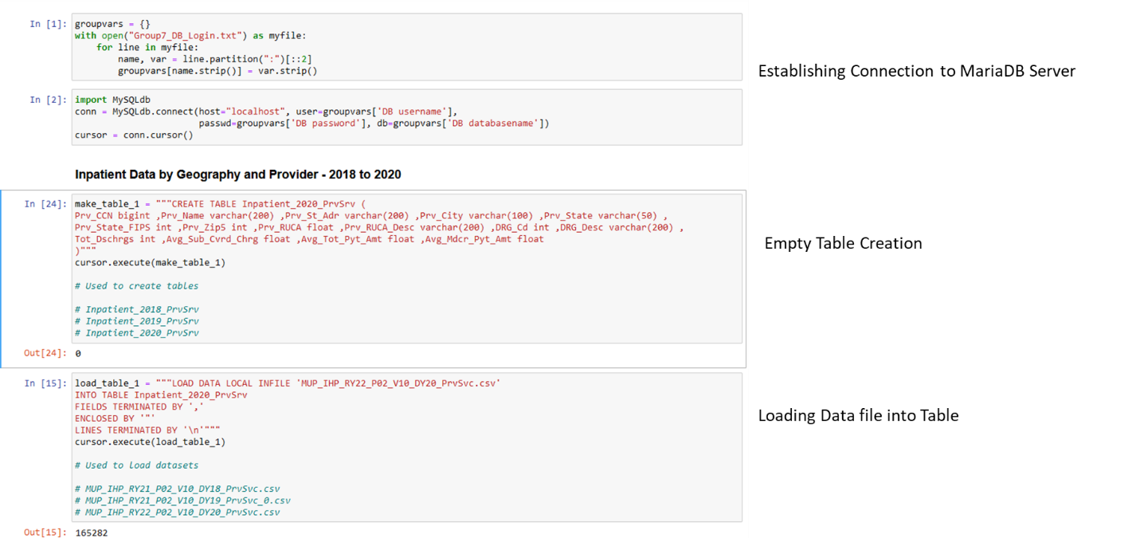

**Figure 1:** Table Creation and Data file upload script for importing the inpatient data files into the group database using Python Jupyter Notebook environment.

The tables imported by this method are mentioned below:

1. Inpatient_2018_PrvSrv
2. Inpatient_2019_PrvSrv
3. Inpatient_2020_PrvSrv
4. Outpatient_2018_PrvSrv
5. Outpatient_2019_PrvSrv
6. Outpatient_2020_PrvSrv
7. MD_PAC_and_Hospice_by_Geo_Prv_20
8. MD_PAC_SNF_2020
9. MD_PAC_HOS_2020

The codes for the creation of all additional tables are included in Appendix B – Section I.

1. Tables created from another table in the database

Certain additional tables were created using SQL queries from existing tables for exploratory data analysis and data visualization. A sample script for the same is shown below:

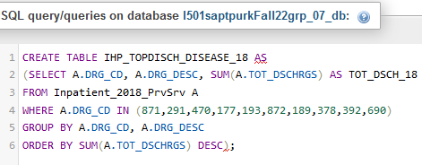

**Figure 2:** SQL Query to create Table IHP_TOPDISCH_DISEASE_18 in the MariaDB group Database.

The tables imported by this method are mentioned below:

1. IHP_TOPDISCH_DISEASE_18
2. IHP_TOPDISCH_DISEASE_19
3. IHP_TOPDISCH_DISEASE_20
4. IHP_TOPDISCH_STATE_18
5. IHP_TOPDISCH_STATE_19
6. IHP_TOPDISCH_STATE_20
7. OPD_TOPDISCH_DISEASE_18
8. OPD_TOPDISCH_DISEASE_19
9. OPD_TOPDISCH_DISEASE_20
10. OPD_TOPDISCH_STATE_18
11. OPD_TOPDISCH_STATE_19
12. OPD_TOPDISCH_STATE_20

The SQL queries for creating remaining tables are provided in Appendix A – Section I.

The final list of tables in the group database is provided below:

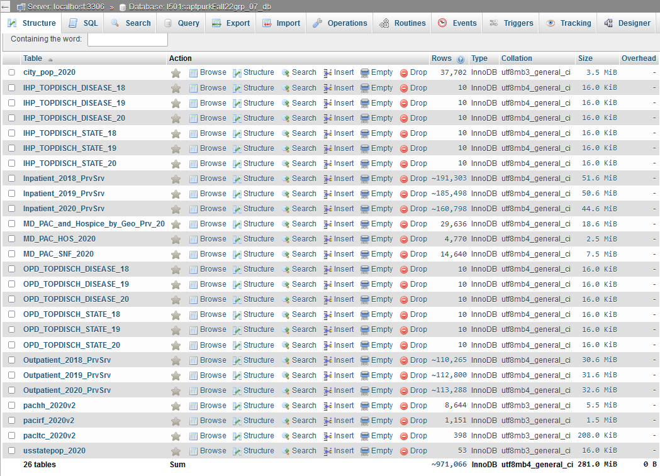**Figure 3:** Complete list of tables in the group database in Maria DB

1. **Data Analysis & Visualization**

Python packages Pandas, NumPy, Matplotlib, Seaborn and Plotly were used for exploratory data analysis and visualization of all relevant datasets. We also used Scikitlearn and Plotly to implement Birch clustering and principal component analysis to determine if there were differences in the services availed for post-acute care and hospice services.

For every analysis, we accessed the data directly from the group database using a SQL Query and constructed a Data frame using pandas that was then used for visualization or analysis.

We used the same process of connecting to the database as mentioned in Figure 1. A list of all python packages we used for our analysis are shown below:

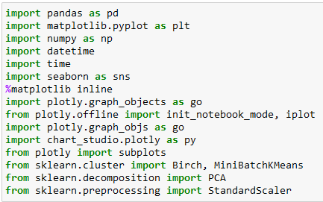

**Figure 4:** List of Python Packages used for Data Analysis and Visualization

The process of analysis and the results obtained are discussed below:

* 1. **Exploratory Data Analysis**
     1. **Visualizing Distribution of Facilities across the US States Using Choropleths**

In order to determine whether the distribution of hospital and hospice facilities was similar across different geographic levels across the US, we studied the distribution of facilities across the US at the State level.

The results are visualized in the form of 2 Choropleths for each type of hospital facility:

1. **Number of Facilities per State**

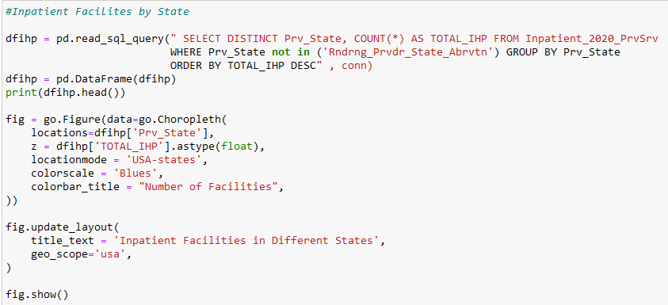

**Figure 5:** Code for visualizing Number of Inpatient Facilities per State on a Choropleth

Codes for visualizing the other types of facilities (outpatient, SNFs, Hospice, IRF, Home Health and LTCs are provided in Appendix B – Section II.

Data for this analysis is plotted in terms of Number of Facilities per State.

1. **Number of Facilities per State normalized to State population**

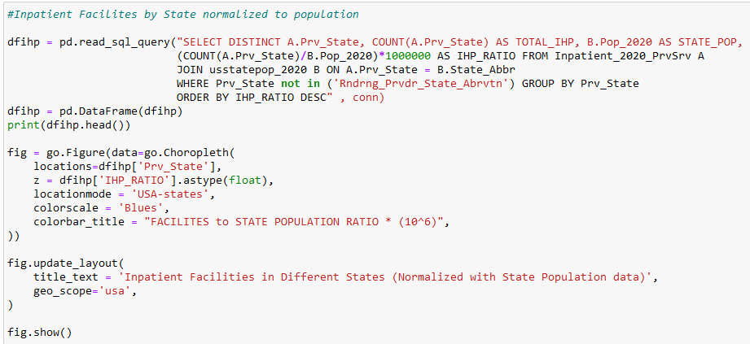

**Figure 6:** Code for visualizing Number of Inpatient Facilities per State normalized with population data on a Choropleth

Codes for visualizing the other types of facilities (outpatient, SNFs, Hospice, IRF, Home Health and LTCs are provided in Appendix B – Section II.

Data for this analysis is plotted as a ratio of Number of Facilities per State normalized to State population which is multiplied by a factor of 106 for visualization.

The results are presented below as 2 choropleths for inpatient, outpatient, SNF and Hospice facilities.

For IRFs, LTCs and Home Health agencies a single choropleth showing the facilities to population ratio is provided.

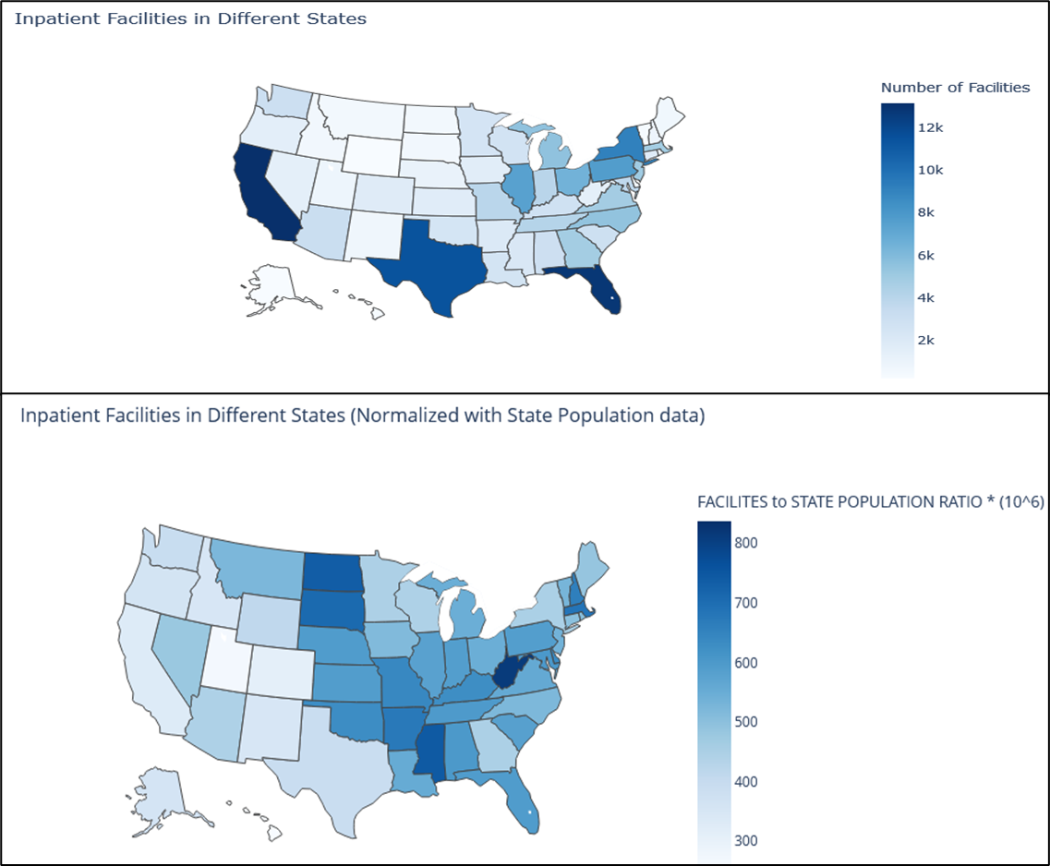

**Figure 7:** Choropleths showing the difference in distribution of inpatient facilities across the different states in the US in terms of number of Facilities (Plot 1) and when normalized with the population of each respective state (Plot 2).

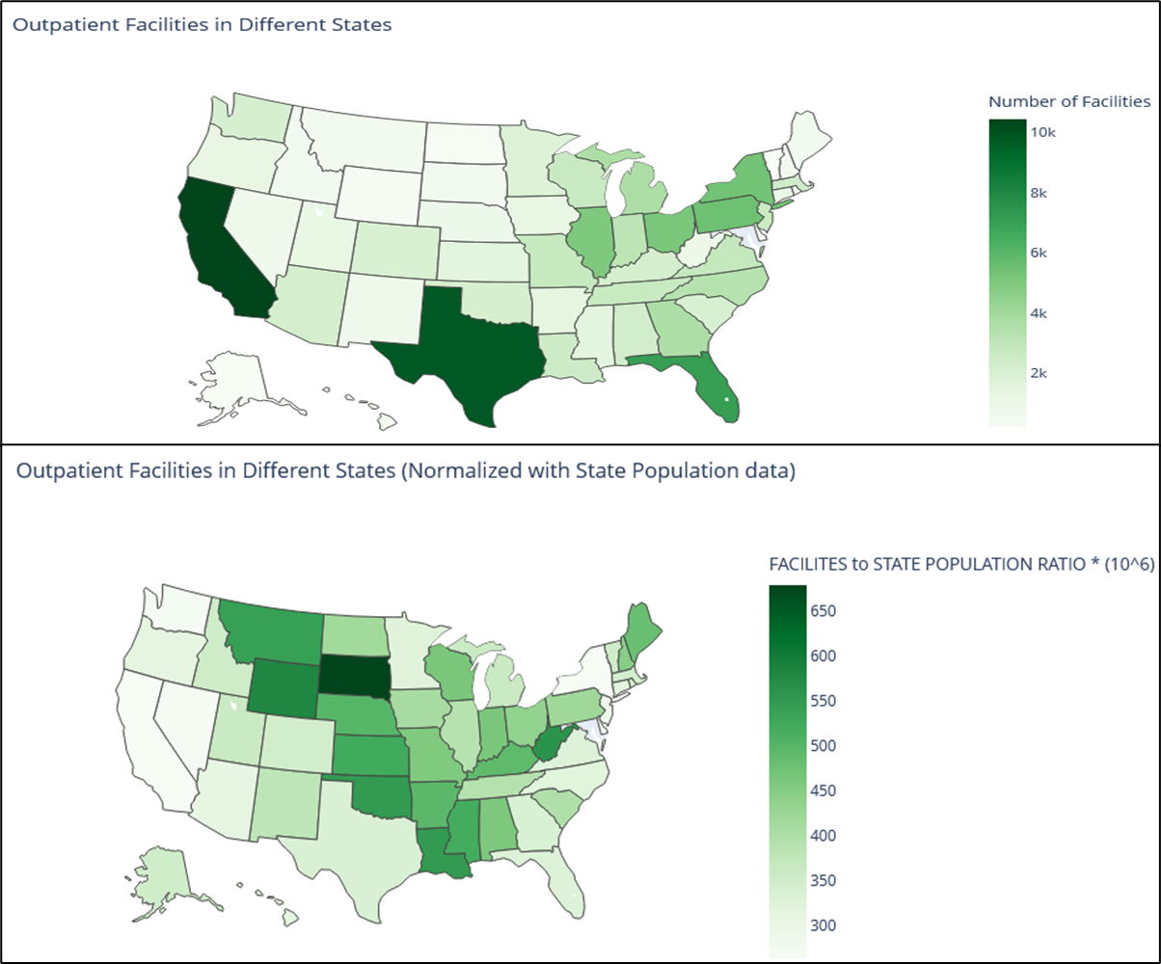

**Figure 8:** Choropleths showing the difference in distribution of outpatient facilities across the different states in the US in terms of number of Facilities (Plot 1) and when normalized with the population of each respective state (Plot 2).

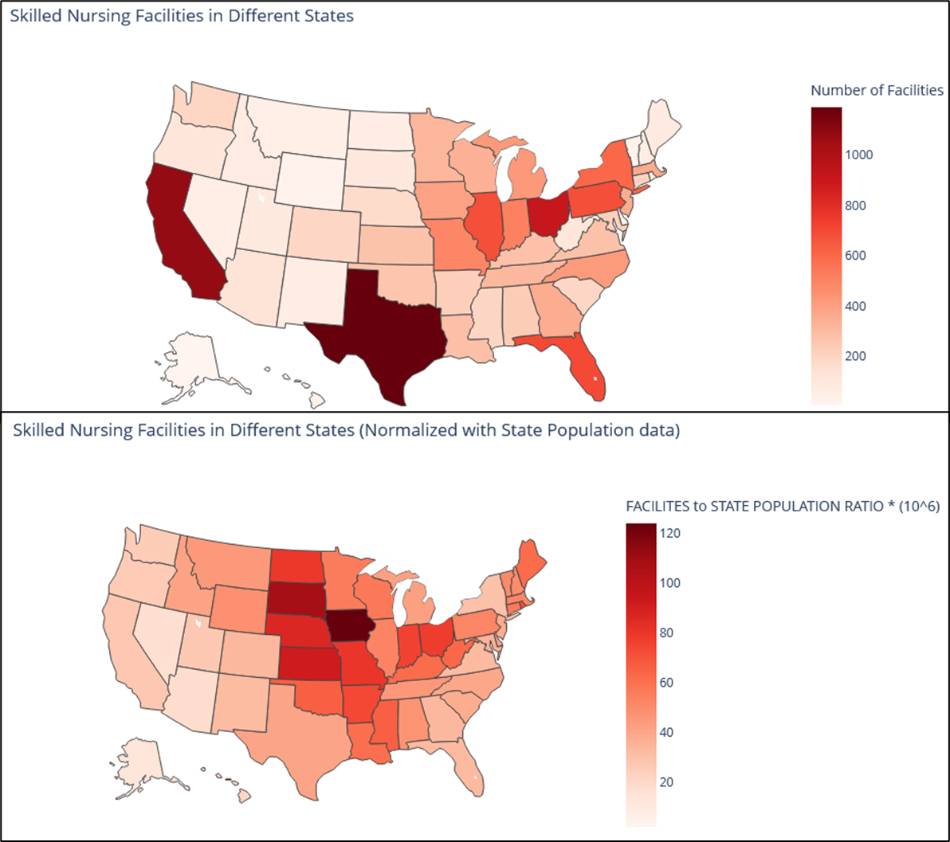

**Figure 9:** Choropleths showing the difference in distribution of Skilled Nursing facilities across the different states in the US in terms of number of Facilities (Plot 1) and when normalized with the population of each respective state (Plot 2).

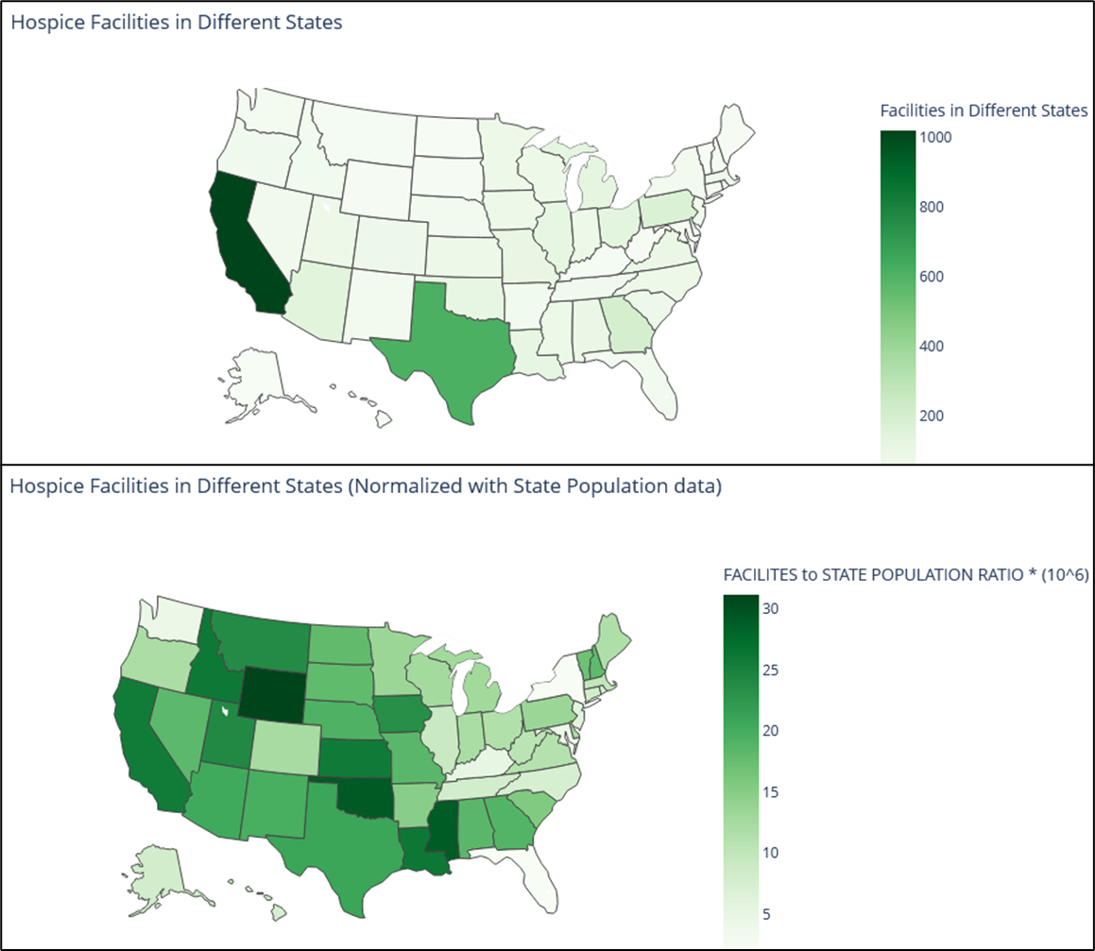

**Figure 10:** Choropleths showing the difference in distribution of Hospice facilities across the different states in the US in terms of number of Facilities (Plot 1) and when normalized with the population of each respective state (Plot 2).

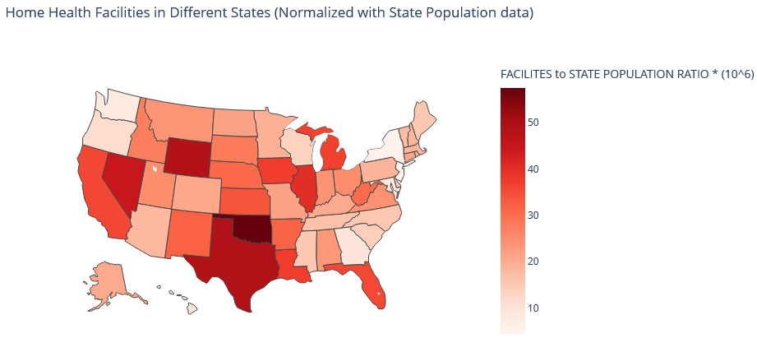

**Figure 11:** Choropleth showing the distribution of ratio of Home Health facilities normalized to population of each respective state.

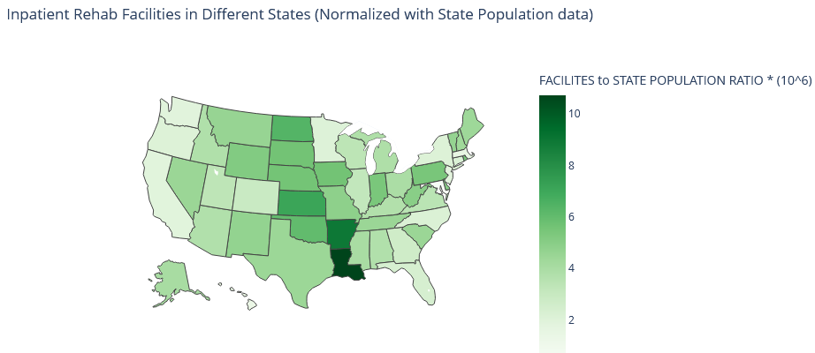

**Figure 12:** Choropleth showing the distribution of ratio of Inpatient Rehab facilities normalized to population of each respective state.

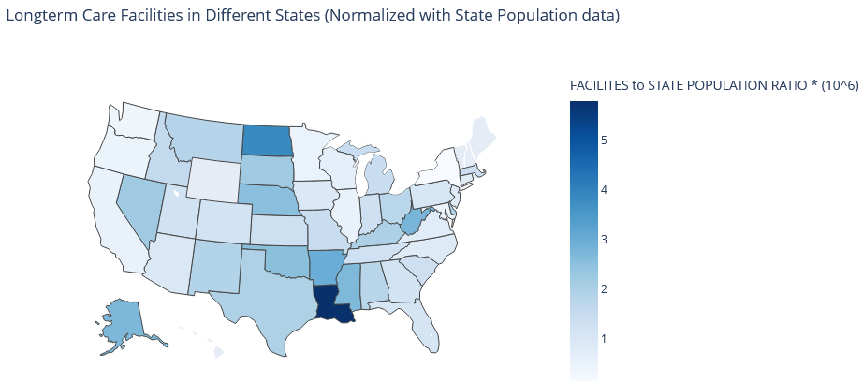

**Figure 13:** Choropleth showing the distribution of the ratio of -Term Care facilities normalized to population of each respective state.

From the results we can conclude that while the highest number of facilities are in the more populated states of California and Texas, when normalized to State population numbers as a metric for access to care, states with fewer people but a proportional number of facilities afford their residents with better access to facilities.

* + 1. **Visualizing Distribution of Facilities across Cities in Indiana Using Bar Graphs**

To determine whether a similar pattern could be seen across cities in a state, we did a comparative analysis of Indiana State cities with the highest numbers of facilities versus cities with the highest facility number to city population ratio, to see if the same cities showed up in both cases.

The codes for the same are provided below:

1. **Number of Facilities per City**

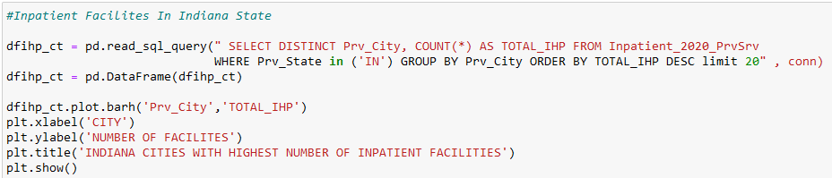

**Figure 14:** Code for visualizing Number of Inpatient Facilities per City in cities in Indiana State on a Horizontal Bar graph

Codes for visualizing the other types of facilities (outpatient, SNFs, Hospice, IRF, Home Health and LTCs are provided in Appendix B – Section III.

Data for this analysis is plotted in terms of Number of Facilities per City.

1. **Number of Facilities per City normalized to City population**

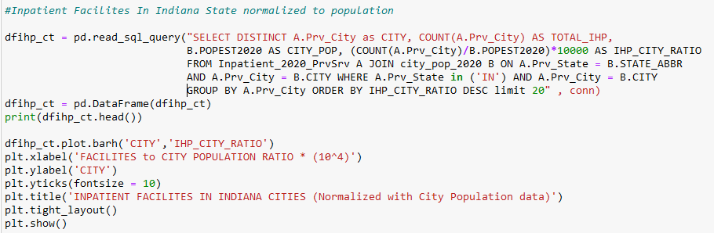

**Figure 15:** Code for visualizing Number of Inpatient Facilities per City in cities in Indiana State normalized with population data on a Horizontal Bar graph

Codes for visualizing the other types of facilities (outpatient, SNFs, Hospice, IRF, Home Health and LTCs are provided in Appendix B – Section III.

Data for this analysis is plotted as a ratio of Number of Facilities per City normalized to City population which is multiplied by a factor of 104 for visualization.

The results are presented below as 2 Bar Graphs for inpatient, outpatient, SNF and Hospice facilities.

For IRFs, LTCs and Home Health agencies a single Bar Graph showing the facilities ratio is provided.

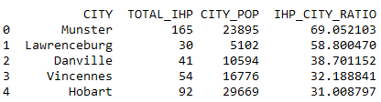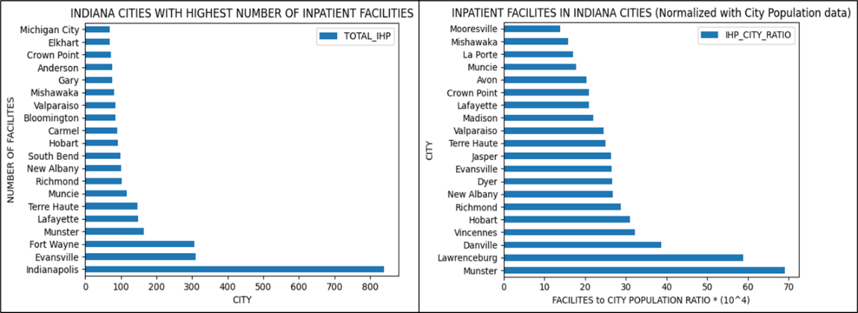

**Figure 16:** Bar Graphs showing the difference in distribution of inpatient facilities in different cities in Indiana in terms of number of Facilities (Plot 1) and when normalized with the population of each respective state (Plot 2).

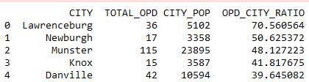

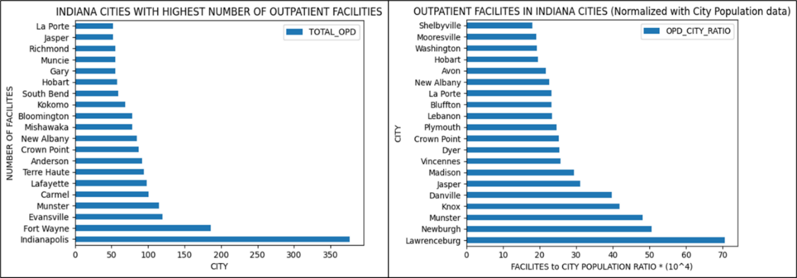

**Figure 17:** Bar Graphs showing the difference in distribution of outpatient facilities in different cities in Indiana in terms of number of Facilities (Plot 1) and when normalized with the population of each respective state (Plot 2).

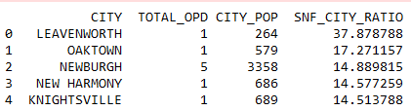

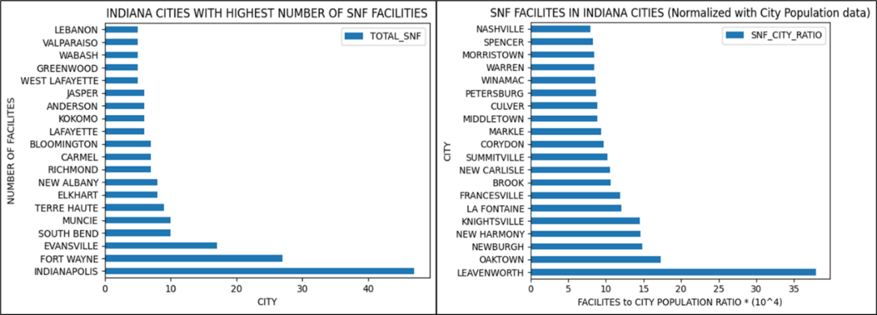

**Figure 18:** Bar Graphs showing the difference in distribution of SNF facilities in different cities in Indiana in terms of number of Facilities (Plot 1) and when normalized with the population of each respective state (Plot 2).

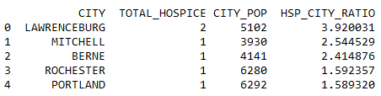

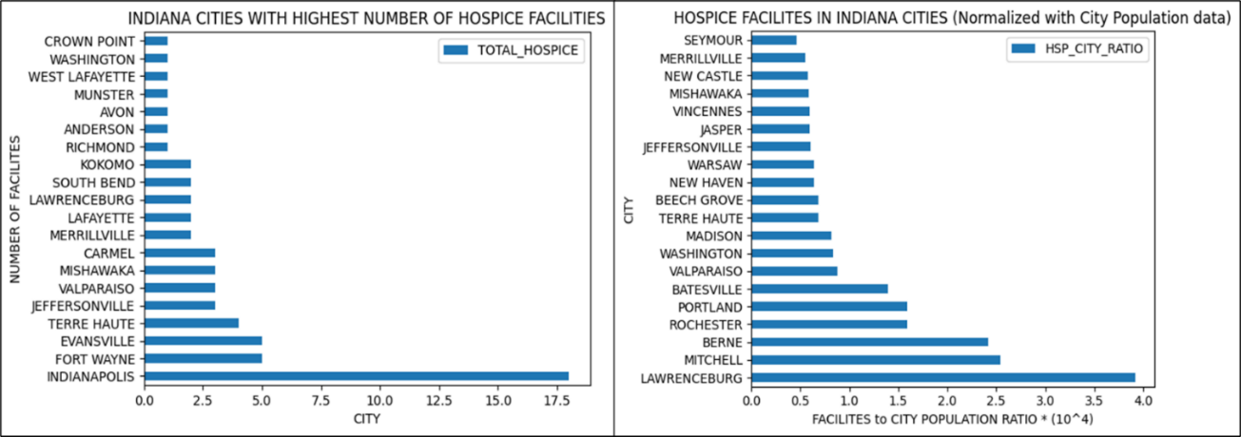

**Figure 19:** Bar Graphs showing the difference in distribution of Hospice facilities in different cities in Indiana in terms of number of Facilities (Plot 1) and when normalized with the population of each respective state (Plot 2).

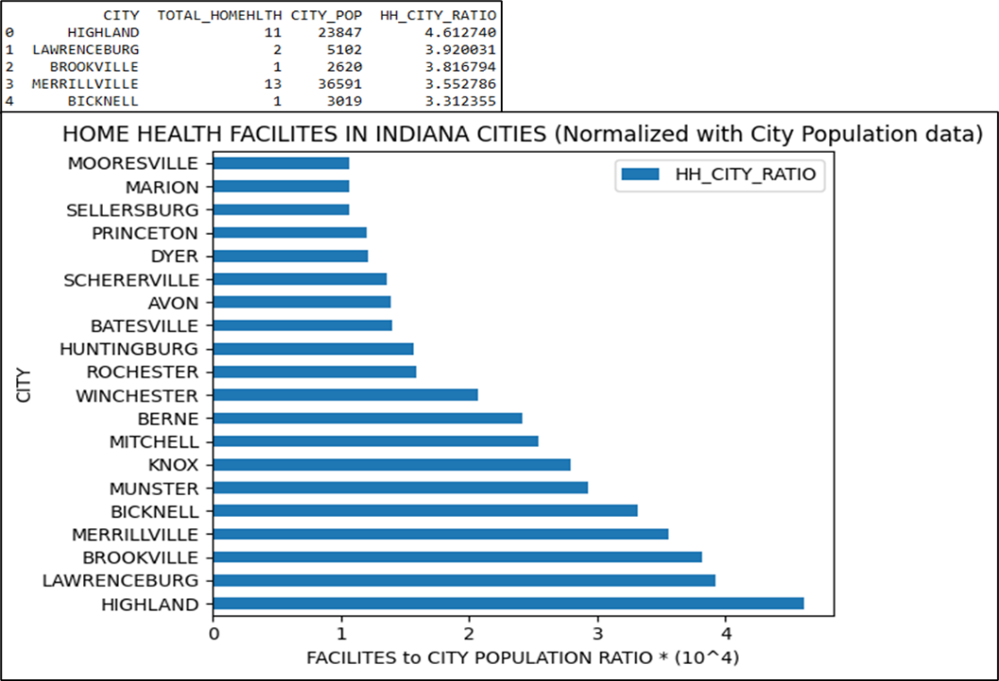

**Figure 20:** Bar Graph showing the distribution of ratio of Home Health facilities normalized to population of the respective city

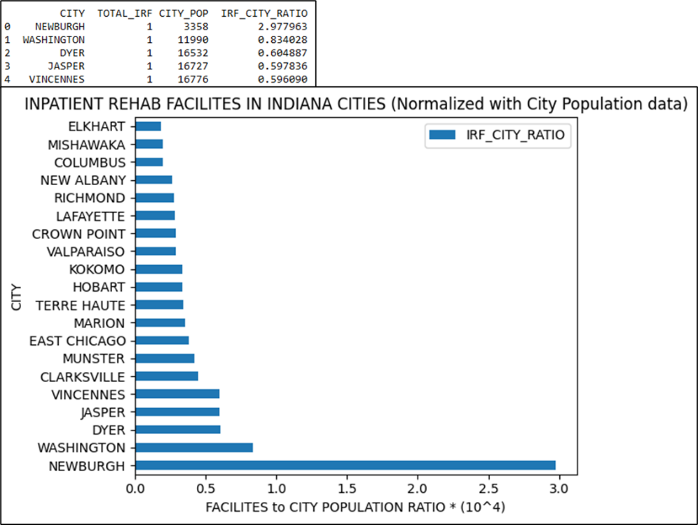

**Figure 21:** Bar Graph showing the distribution of ratio of IRF facilities normalized to population of the respective city

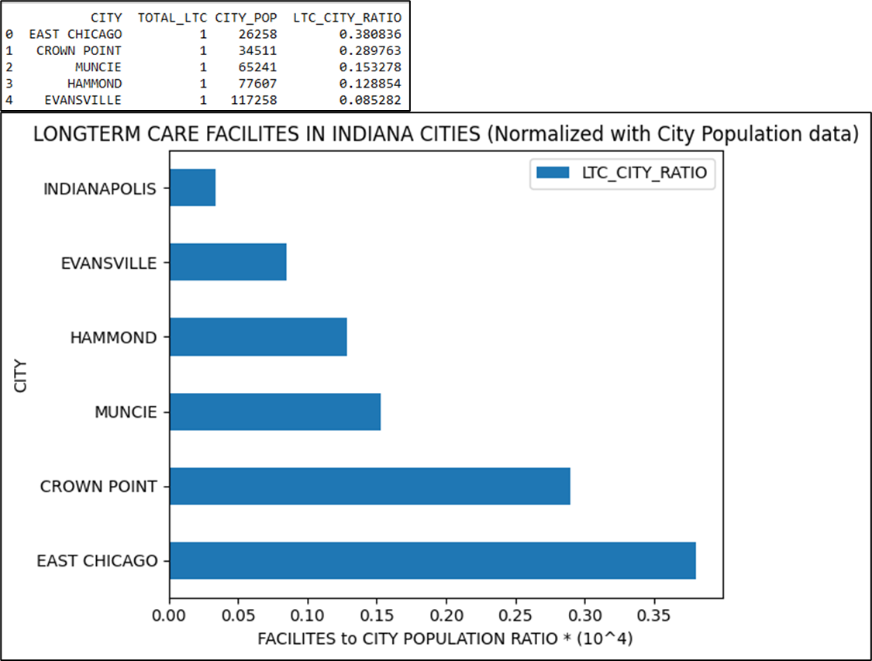

**Figure 22:** Bar Graph showing the distribution of ratio of LTC facilities normalized to population of the respective city

From the results, it is evident that a similar pattern to what was observed at the State level can also be seen at the city level within Indiana state.

* + 1. **Change in most availed inpatient and outpatient services before and during the COVID pandemic**

One of our research questions was to ascertain whether there was a change in the most common indications patients came in for before and during the COVID pandemic i.e., between 2018 and 2020. To address this, we identified the inpatient and outpatient services with the highest patient counts (TOT_DSCHRGS column in table) at the state level across the US. We also looked at the changes in overall patient counts during this period to determine if a similar trend was observed. The codes for the same are provided below:

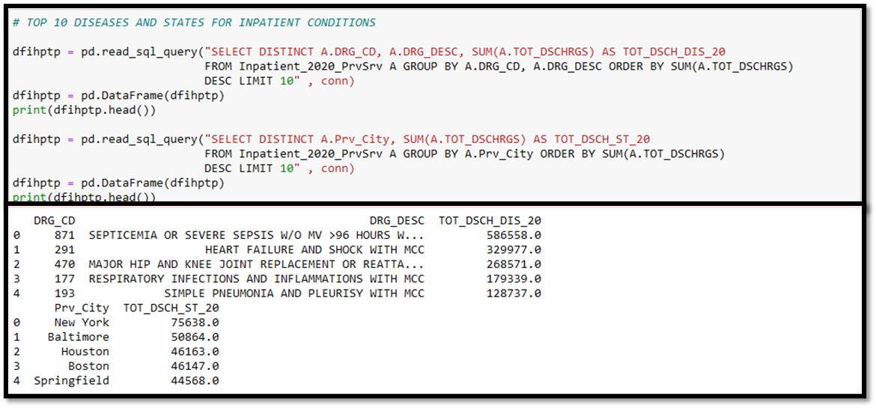

**Figure 23:** Code and partial output for determining top 10 inpatient services availed in the US and states with the maximum patient counts

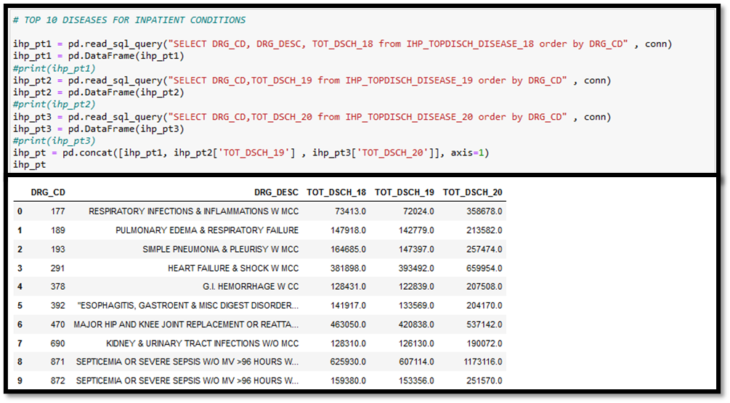

**Figure 24:** Code and output for determining patient counts for top 10 inpatient services availed in the US during 2018-2020

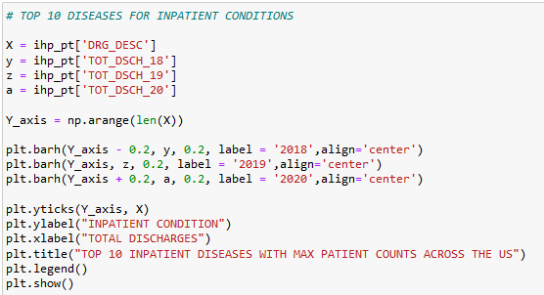

**Figure 25:** Code for visualizing top 10 inpatient services availed in the US during 2018-2020 on a horizontal bar graph

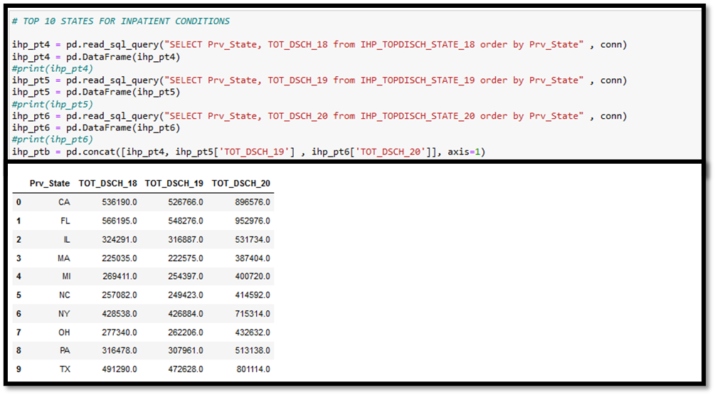

**Figure 26:** Code and output for visualizing top 10 states availing inpatient services availed in the US during 2018-2020 on a horizontal bar graph

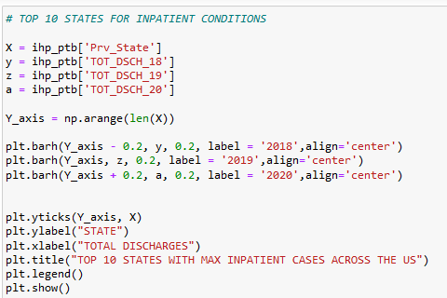

**Figure 27:** Code for visualizing top 10 states availing inpatient services availed in the US during 2018-2020 on a horizontal bar graph

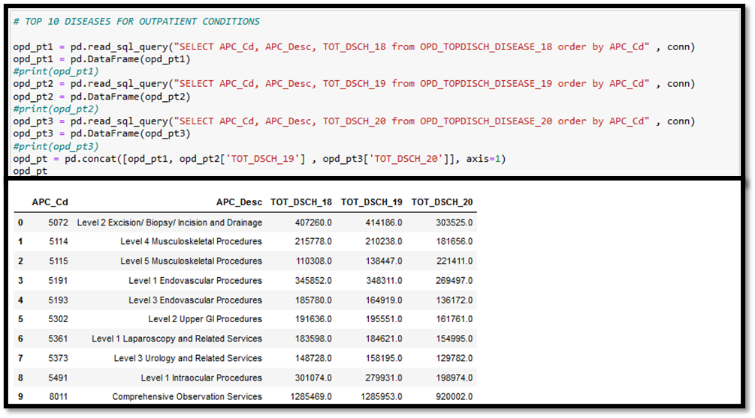

**Figure 28:** Code and output for determining top 10 outpatient services availed in the US and states with the maximum patient counts

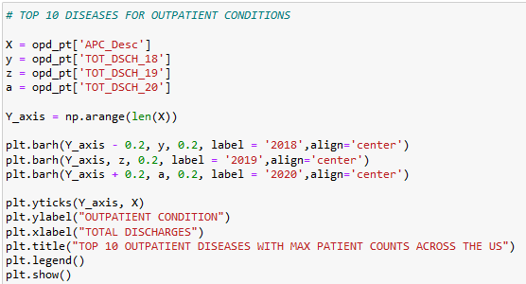

**Figure 29:** Code for visualizing top 10 outpatient services availed in the US during 2018-2020 on a horizontal bar graph

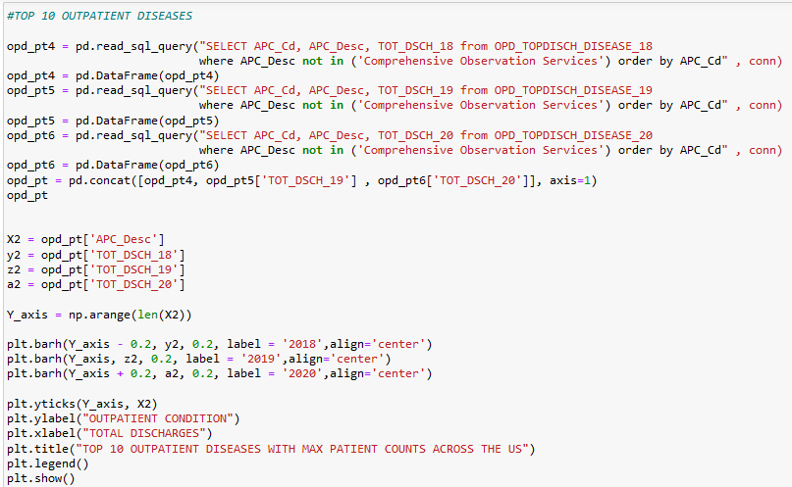

**Figure 30:** Code for visualizing top 10 outpatient services availed in the US during 2018-2020 on a horizontal bar graph

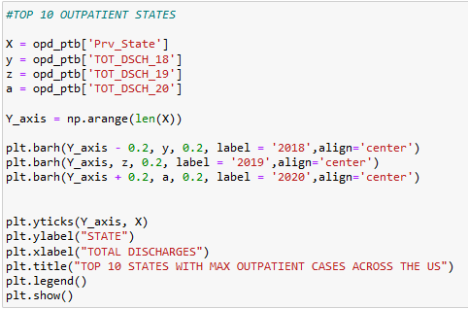

**Figure 31:** Code for visualizing top 10 states availing outpatient services availed in the US during 2018-2020 on a horizontal bar graph

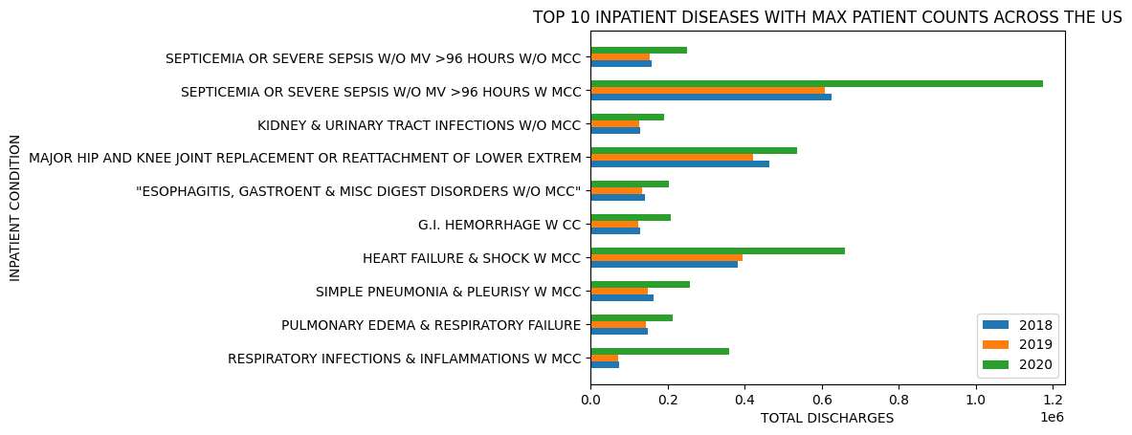

**Figure 32:** Changes in top 10 inpatient services in terms of patient counts accessed during 2018-2020 across the US

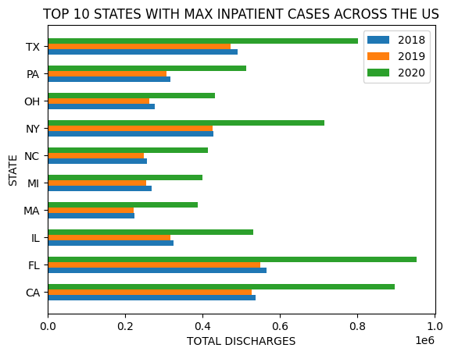

**Figure 33:** Changes in top 10 states availing inpatient services in terms of patient counts during 2018-2020 across the US.

From the inpatient data, we can conclude that 2020 saw a major spike in access to inpatient services related to sepsis, heart failure and respiratory infections which were commonly associated with COVID-19 infections.

There was also the expected spike in patient counts during 2020 compared with previous years, which correlates with the higher hospitalization rates seen during the pandemic.

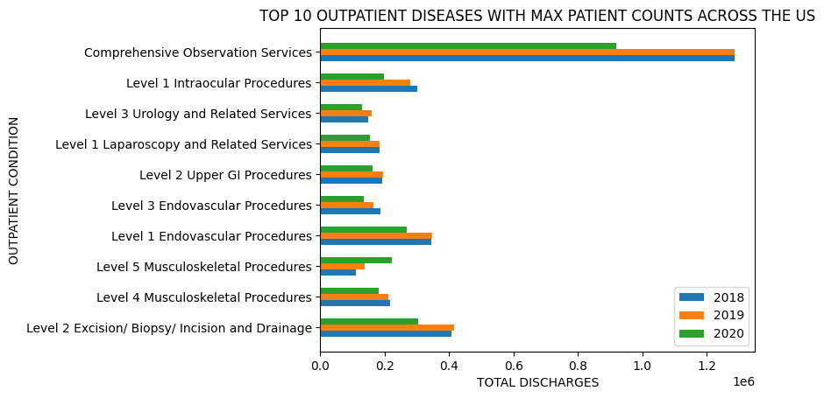

**Figure 34:** Changes in the top 10 outpatient services in terms of patient counts accessed during 2018-2020 across the US

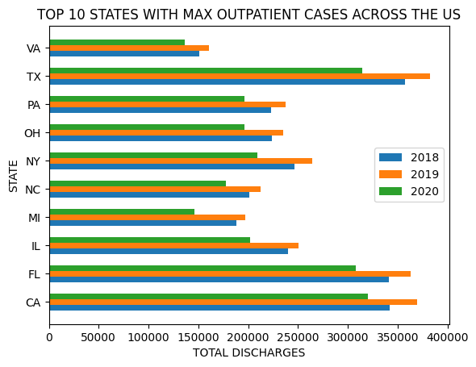

**Figure 35:** Changes in top 10 states availing outpatient services in terms of patient counts during 2018-2020 across the US

From the outpatient data, we can conclude that there was a slight decrease in access to services in 2020 as compared to previous years since people were advised to stay home and step out only in case of emergencies. The same trend was observed in patient counts across different states.

**5.1.4 Difference in Cost for the Most Expensive Inpatient and Outpatient Services**

To assess if there was a difference in cost of Medicare offered services across the US, we looked at the maximum, minimum and average cost of the most expensive inpatient and outpatient services in 2020.

We also performed a similar analysis for the most accessed services seen in the section 5.1.3 at the state level and within cities in the state of Indiana. The codes and the results for the same are provided below:

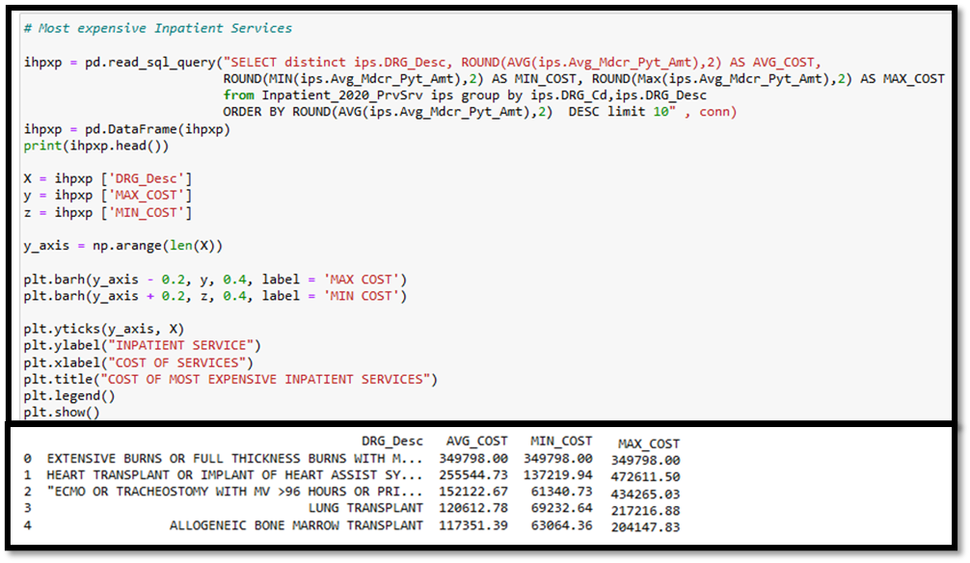

**Figure 36:** Code and partial output for assessing the difference in cost of the most expensive inpatient services covered by Medicare in the US on a horizontal Bar graph

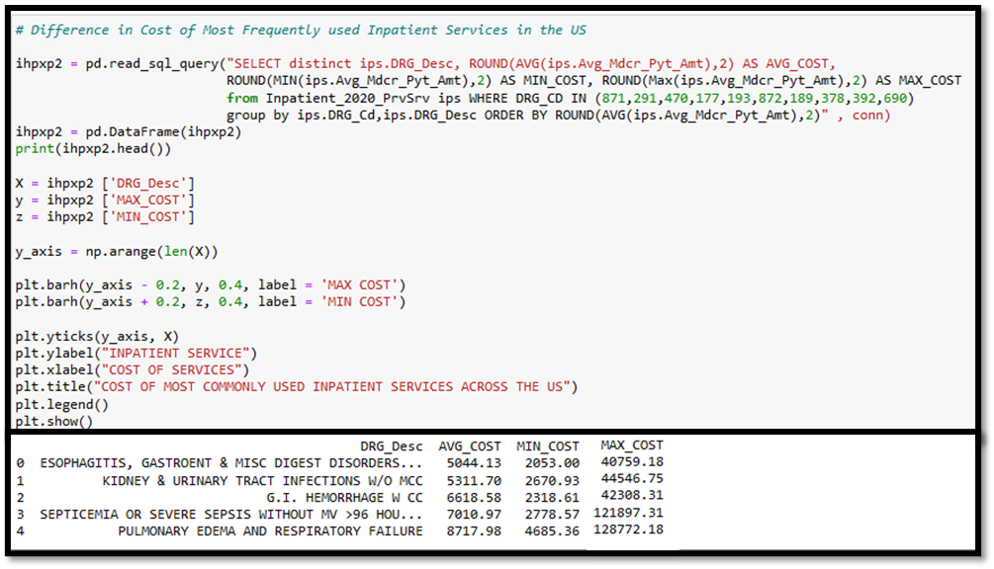

**Figure 37:** Code and partial output for assessing the difference in cost of the most availed inpatient services covered by Medicare in the US on a horizontal Bar graph

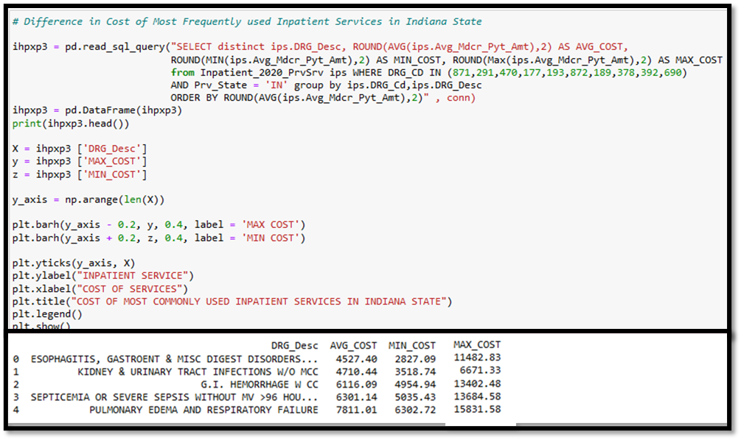

**Figure 38:** Code and partial output for assessing the difference in cost of the most availed inpatient services covered by Medicare within cities in Indiana on a horizontal Bar graph

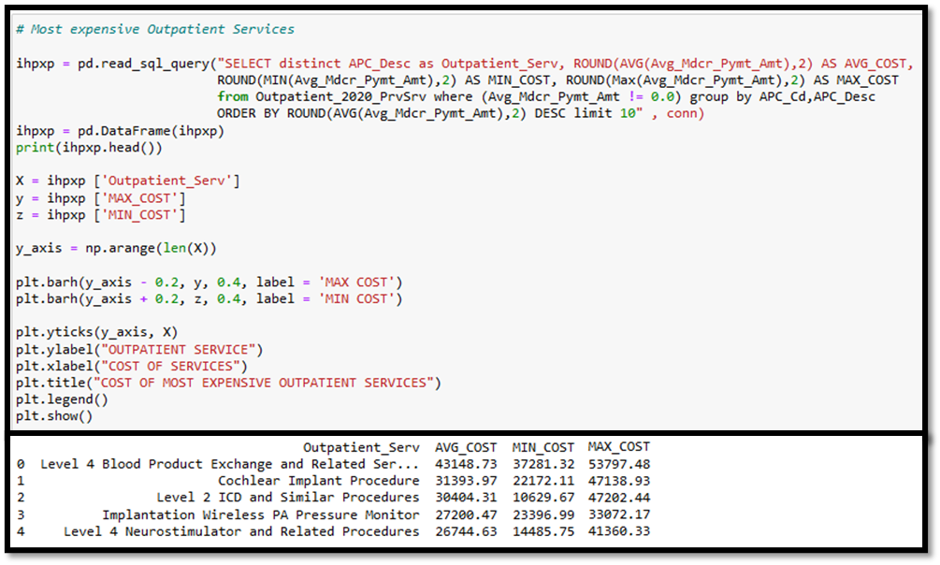

**Figure 39:** Code and partial output for assessing the difference in cost of the most expensive outpatient services covered by Medicare in the US on a horizontal Bar graph

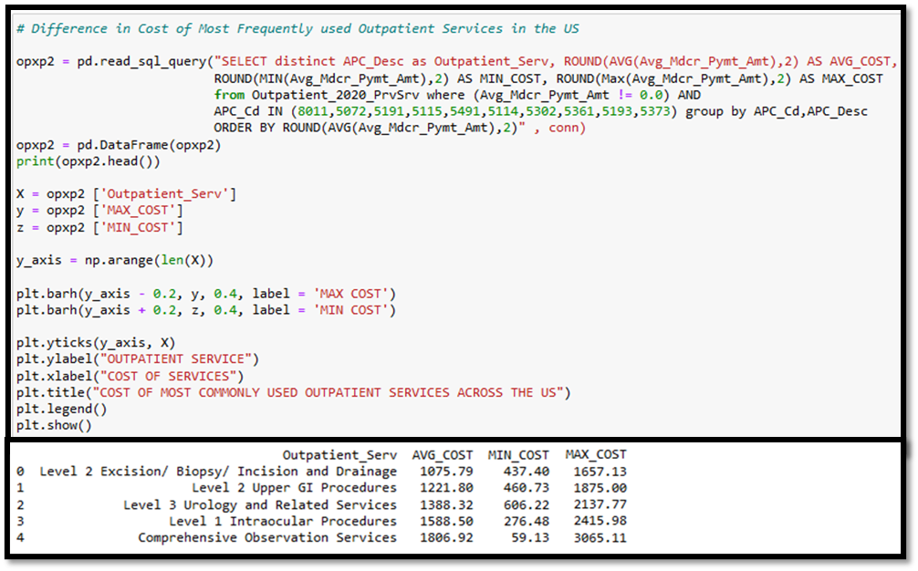

**Figure 40:** Code and partial output for assessing the difference in cost of the most availed outpatient services covered by Medicare in the US on a horizontal Bar graph

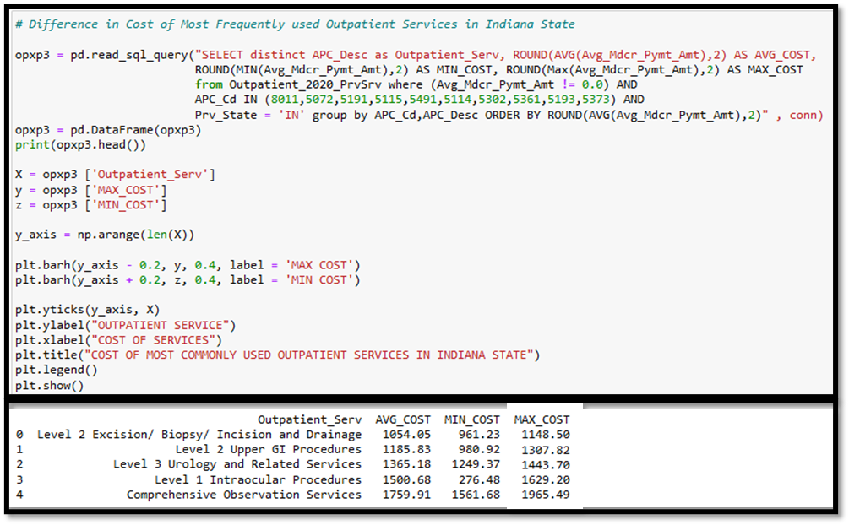

**Figure 41:** Code and partial output for assessing the difference in cost of the most availed outpatient services covered by Medicare within cities in Indiana on a horizontal Bar graph

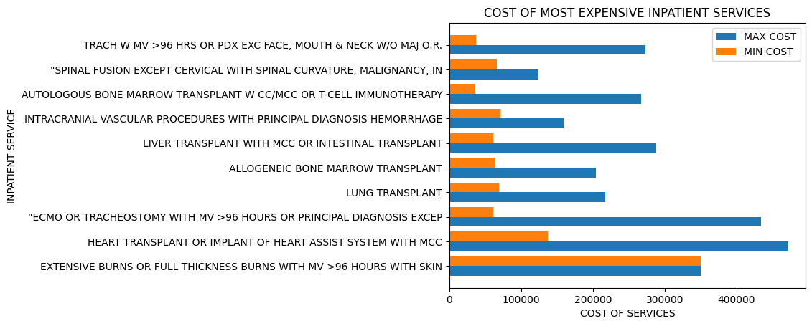

**Figure 42:** Differences in cost of the most expensive inpatient services covered by Medicare in the US visualized on a horizontal Bar graph

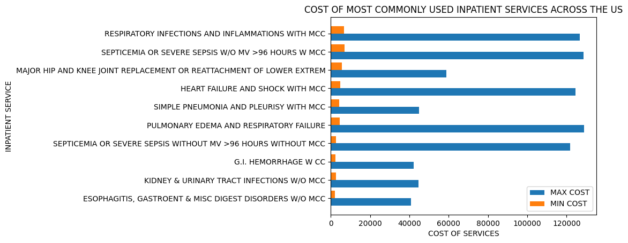

**Figure 43:** Differences in cost of the most availed inpatient services covered by Medicare in the US visualized on a horizontal Bar graph

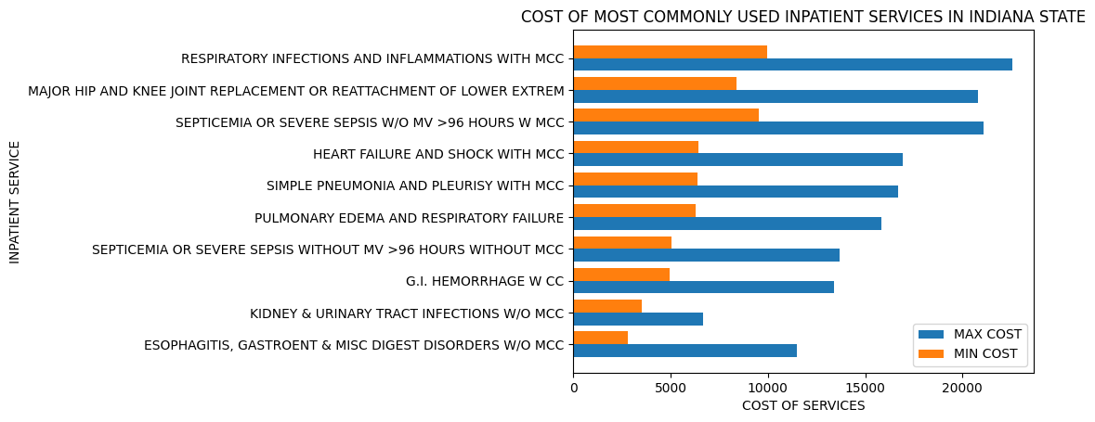

**Figure 44:** Differences in cost of the most availed inpatient services covered by Medicare within cities in Indiana visualized on a horizontal Bar graph

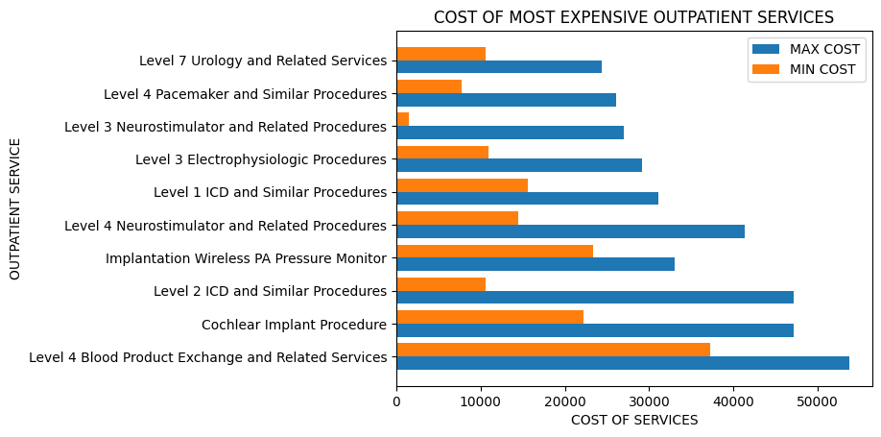

**Figure 45:** Differences in cost of the most expensive outpatient services covered by Medicare in the US visualized on a horizontal Bar graph

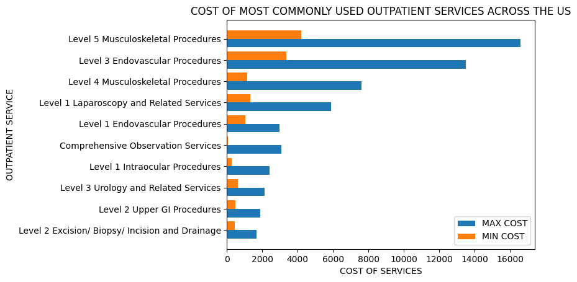

**Figure 46:** Differences in cost of the most availed outpatient services covered by Medicare in the US visualized on a horizontal Bar graph

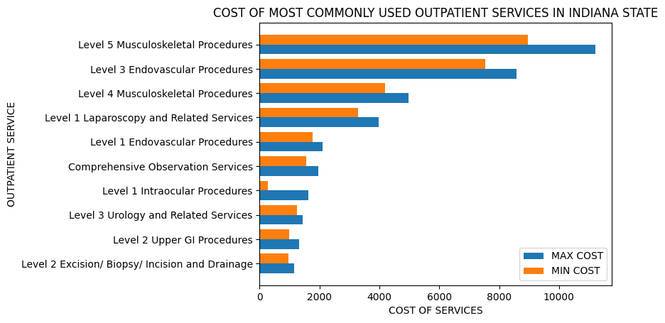

**Figure 47:** Differences in cost of the most availed outpatient services covered by Medicare within cities in Indiana visualized on a horizontal Bar graph

From the results, we can surmise that there is a steep difference in the cost of inpatient services across the US for the most expensive services as well as for those most availed. This difference can also be seen within cities in a state but to a lesser extent.

A similar pattern is seen with outpatient services to a lesser extent since outpatient services are not as expensive as inpatient services.

* + 1. **Distribution in PAC and Hospice Patients by Gender**

Next, we assessed similar differences in access to PAC and Hospice services. We determined this by looking at distribution of patients by gender who availed SNF and Hospice facilities in different states and the top 20 cities with the highest male patient counts.

The code and the results for the same are provided below:

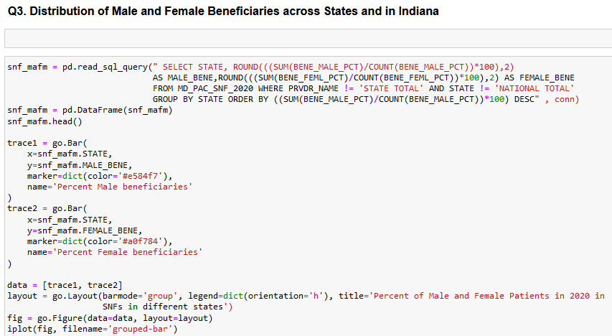

**Figure 48:** Code for assessing differences in access to SNF facilities by gender at the state level, on a bar graph

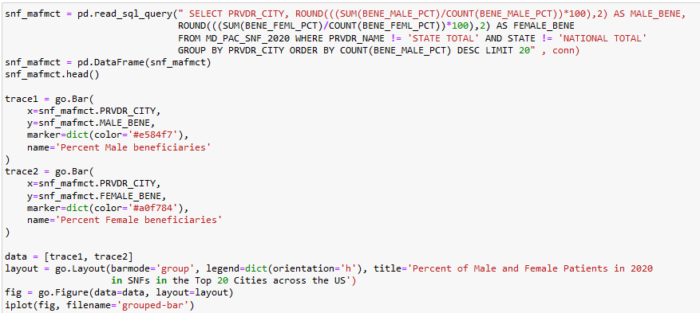

**Figure 49:** Code for assessing differences in access to SNF facilities by gender in cities with the cities with the top 20 highest male patient counts, on a bar graph

The codes for differences in access to Hospice services are included in Appendix B – Section IV.

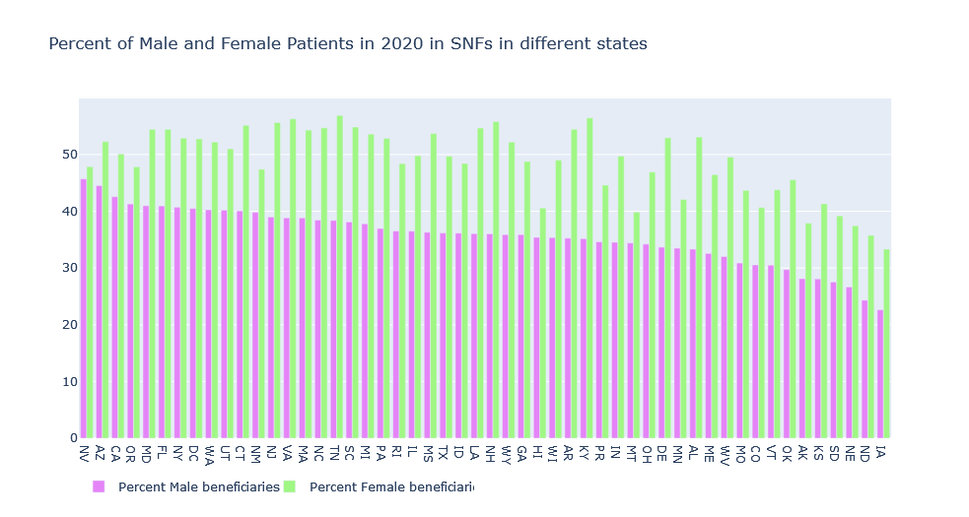

**Figure 50:** Differences in access to SNF facilities by gender at the state level, on a bar graph

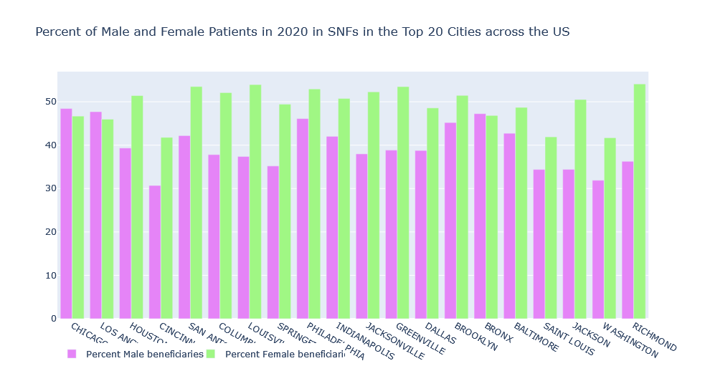

**Figure 51:** Differences in access to SNF facilities by gender in cities with the top 20 male patient counts, on a bar graph

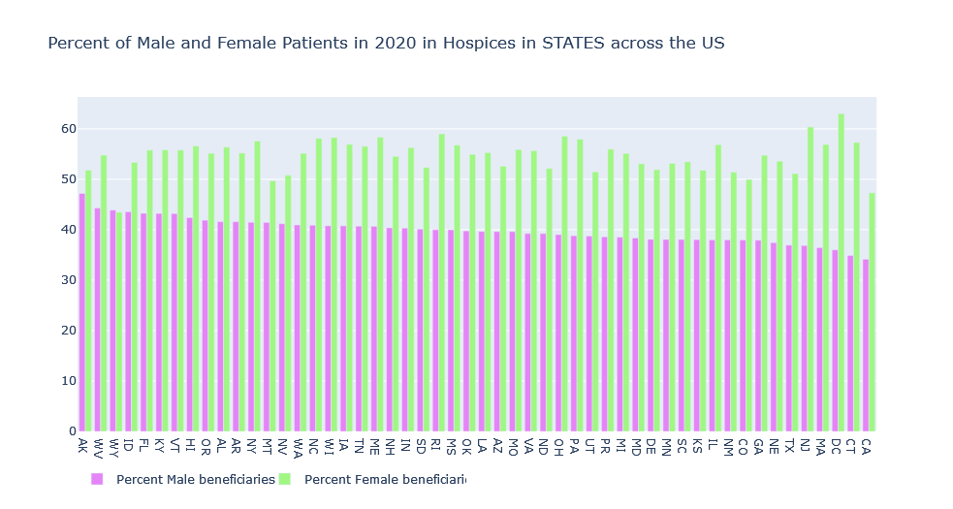

**Figure 52:** Differences in access to SNF facilities by gender at the state level, on a bar graph

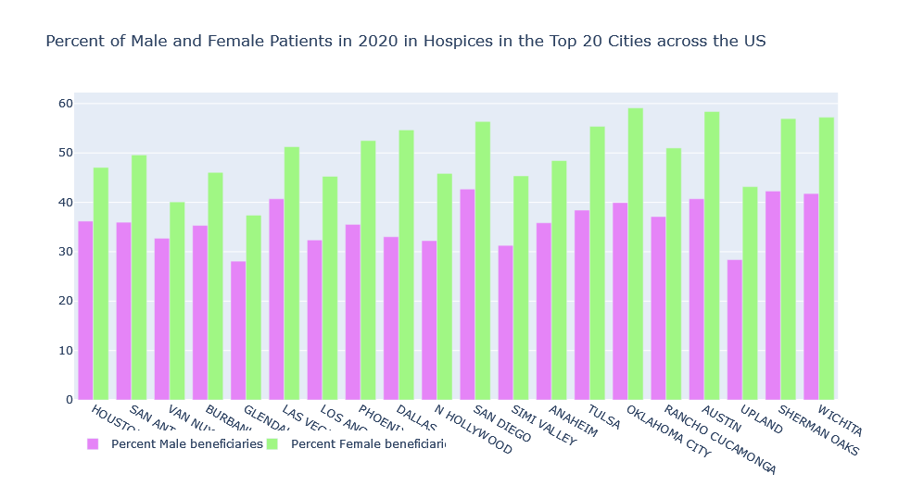

**Figure 53:** Differences in access to Hospice facilities by gender in cities with the top 20 male patient counts, on a bar graph

Based on the results we can conclude that female patients consistently access PAC and Hospice facilities more than male patients at all geographic levels.

**5.1.5** **Distribution in PAC and Hospice Patients by Ethnicity**

In a similar fashion, we assessed differences in access to PAC and Hospice services by ethnicity at various geographic levels.

The code and the results for the same are provided below:

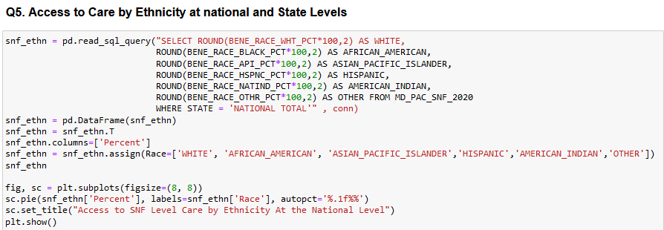

**Figure 54:** Code for assessing differences in access to SNF facilities by ethnicity at the national level using a pie chart

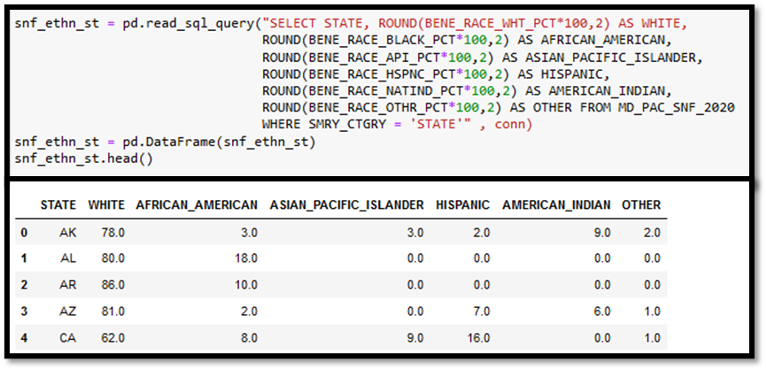

**Figure 55:** Code and partial output to assess differences in access to SNF facilities by ethnicity in each state

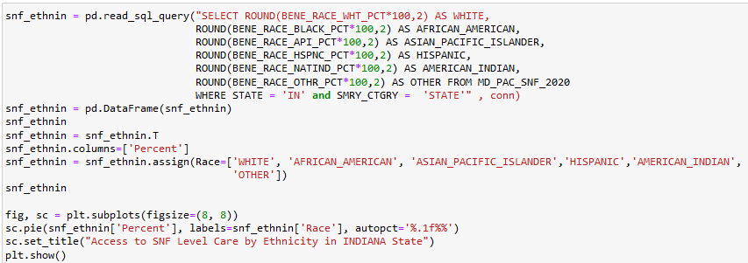

**Figure 56:** Code for assessing differences in access to SNF facilities by ethnicity in the state of Indiana, using a pie chart

The codes for differences in access to Hospice services are included in Appendix B – Section V.

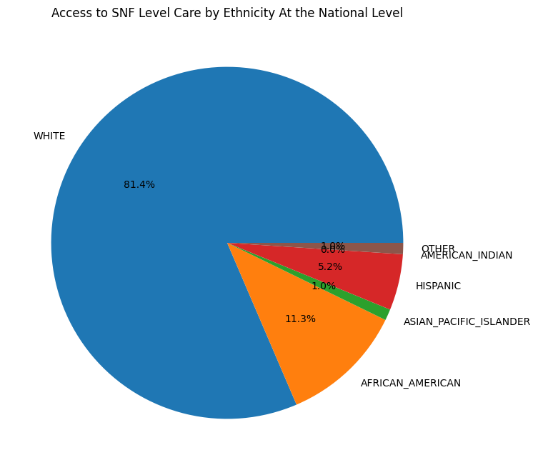

**Figure 57:** Differences in access to SNF facilities by ethnicity at the national level using a pie chart

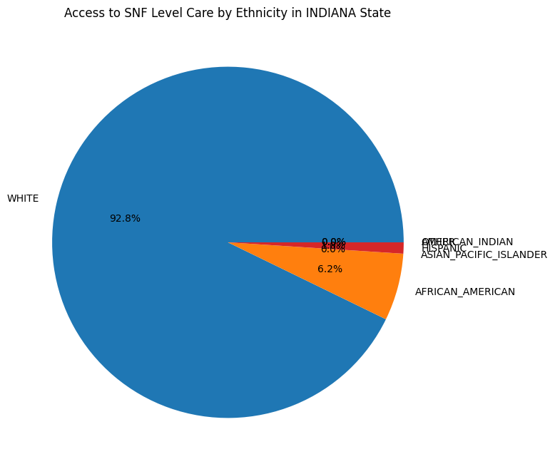

**Figure 58:** Differences in access to SNF facilities by ethnicity in Indiana State, using a pie chart

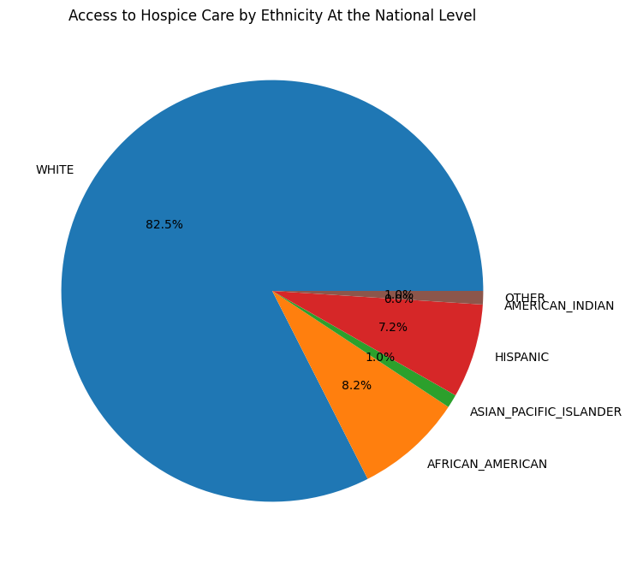

**Figure 59:** Differences in access to Hospice facilities by ethnicity at the national level using a pie chart

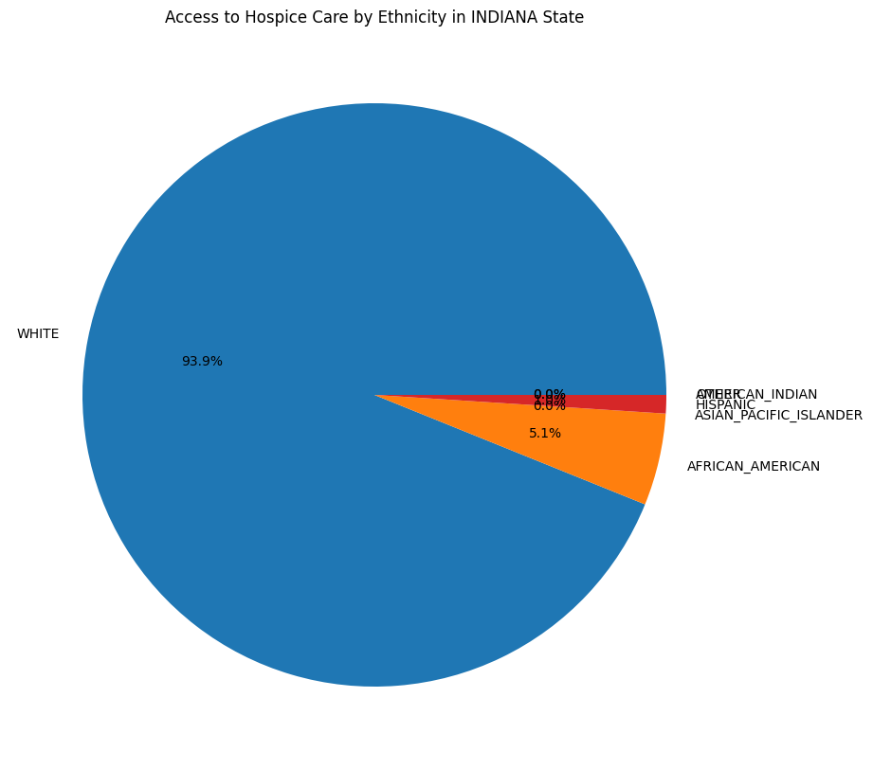

**Figure 60:** Differences in access to Hospice facilities by ethnicity in Indiana State, using a pie chart

The results demonstrate that more than 80% of PAC and Hospice facilities are accessed by White patients. African American and Hispanic patients are the next highest with some differences between national and Indiana state levels depending on facility type. Other ethnicities together make up less than 5% of the demographic at most geographic levels, except in certain specific states where some of these ethnicities have a larger presence.

* 1. **Clustering Post-Acute Care and Hospice facilities to assess differences in access to care**

Another one of our proposed research questions was whether we could show a difference in access to PAC and Hospice services available to Medicare patients that could be discerned by looking at characteristics of individual facilities such as details of hospital rating criteria, patient episode lengths, days of services offered, percentage of patients availing services by gender, ethnicity and chronic conditions treated.

We dropped the Hospital rating criteria early on in our analysis, since the data available provided ratings for a very small number of providers.

Using the other criteria mentioned above, we attempted to cluster the 5 different types of facilities into distinct groups with unique characteristics. The main steps involved in this process were:

1. Using Birch Clustering to segregate different types of facilities
2. Visualization of Cluster results based on the top 2 contributing components using Principal Component Analysis (PCA)
3. Studying distribution of certain features in individual clusters to attempt to identify features contributing most variation

We discuss each step in further detail for one type of facility below with accompanying codes and visualizations.

For the other four types, the summarized results and visualizations are included here, and the codes are included in Appendix B - Section VI.

**5.2.1 Clustering SNF Facilities using Birch**

1. For each facility subset we pulled a list of about 30-32 features and added them into a data frame.

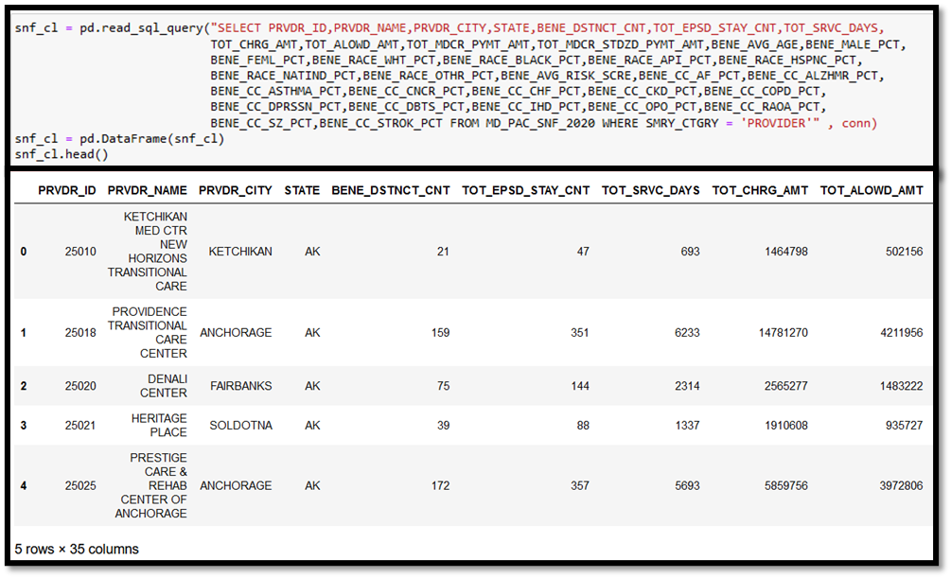

**Figure 61:** Creating a data frame for 35 features for SNF facilities for cluster analysis

1. Provider identifier details such as Provider ID, Provider Name, City and State are dropped from the clustering data frame.

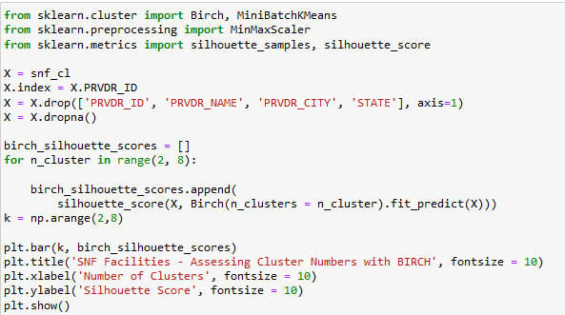

**Figure 62:** Dropping provider identifier details and running a loop to determine best number of clusters to segregate SNF facilities

1. To assess the best number of clusters for each dataset, a loop was used to assess which cluster number gave the best silhouette score. The results were visualized on a Bar graph.

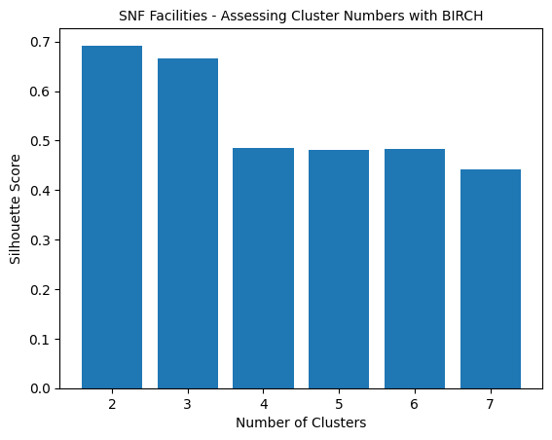

**Figure 63:** Visualizing the clustering loop results in determining the best number of clusters to segregate SNF facilities. N=2 gave the best results.

1. Clustering is redone with the appropriate number of clusters and the silhouette score is printed. The number of datapoints in each cluster are then determined.

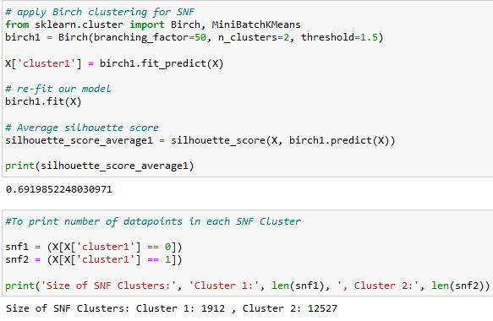

**Figure 64:** Clustering is redone with an appropriate number of clusters (n=2 for SNFs) and the silhouette scores are printed. The number of data points in each cluster is also printed.

**5.2.2 Cluster Visualization with Principal Component Analysis**

1. To perform PCA, the features from the data frame are first transformed to a standardized scale to minimize variation due to difference in scale of various features.

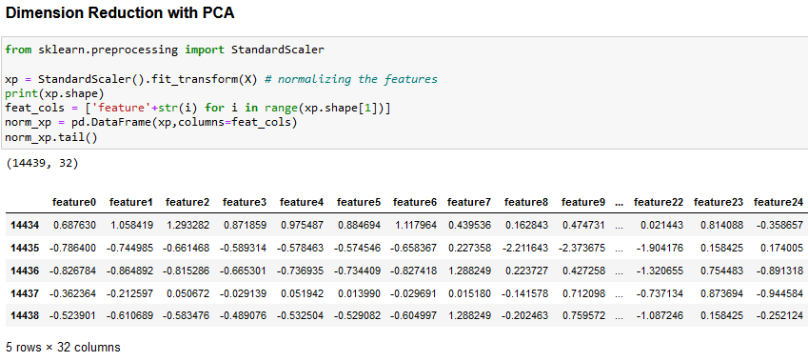

**Figure 65:** Standardized scalar transformation of SNF features for PCA analysis.

1. A PCA loop is run by sequentially increasing the number of components until 90% of the variation is explained. The variation explained by each component in descending order and the final number of components required to explain 90% of the variation are printed.

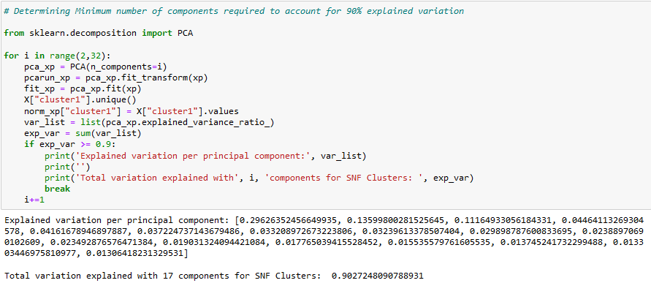

**Figure 66:** Looped PCA analysis of scaled SNF features to determine the number of components that account for 90% of the explained variation. The explained variation for each principal component in descending order and the result is printed in the output.

1. A scatter plot is used to visualize the clusters with the top 2 principal components accounting for the maximum variation in the data.

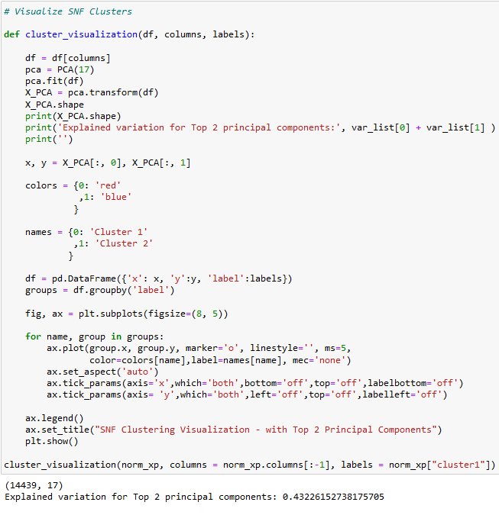

**Figure 67:** Code for visualizing SNF clusters on a scatter plot using the top 2 principal components that account for the maximum amount of explained variation. The explained variation is printed in the output.

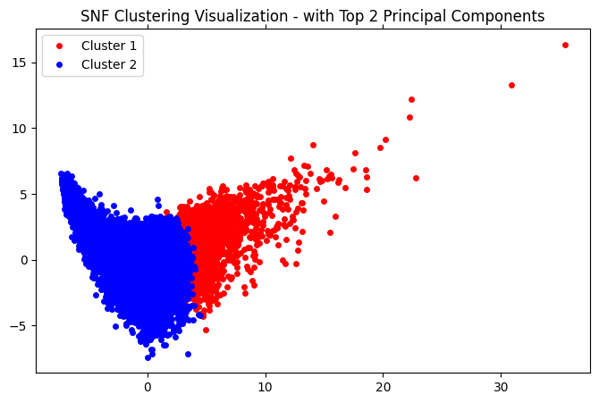

**Figure 68:** Scatter plot to visualize SNF clusters using the top 2 principal components that account for the maximum amount of explained variation

**5.2.3 Studying Distribution of datapoints for Individual clusters to determine important components**

For facility types where 2 or more clusters showed distinct distribution of datapoints, the distribution of the following features was studied for each cluster using a grouped boxplot:

1. Total Medicare charges
2. Distinct number of patients
3. Total Service days
4. Percent of Patients who have cancer as a chronic or primary diagnosed condition

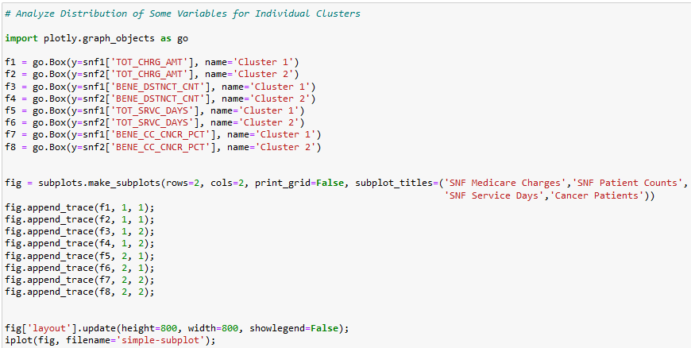

**Figure 69:** Code for grouped Boxplot to visualize distribution of datapoints for certain features in the individual SNF clusters

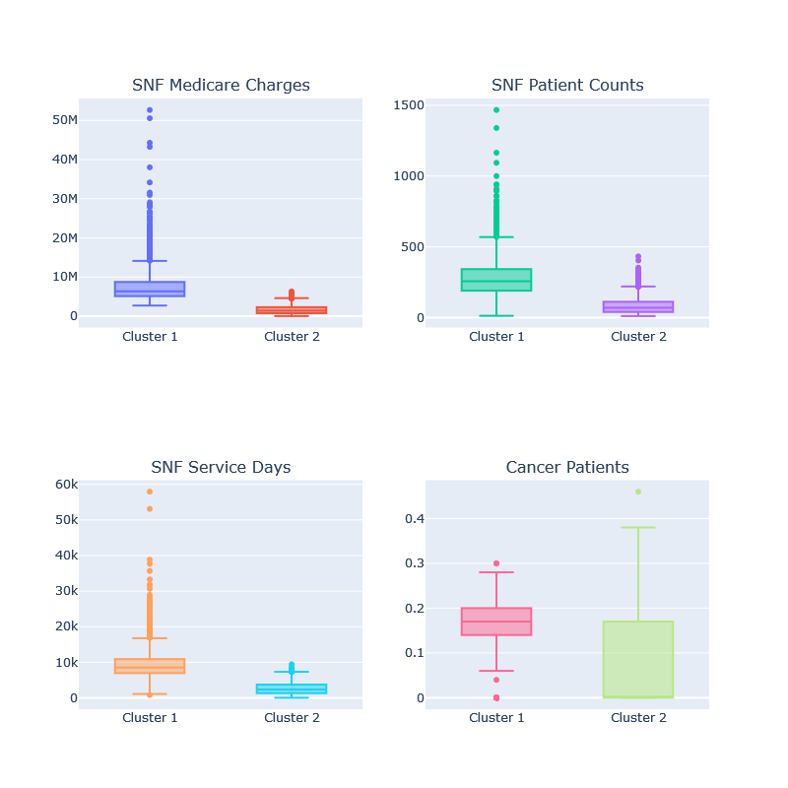

**Figure 70:** Grouped Boxplot to visualize distribution of datapoints for certain features in the individual SNF clusters

The clustering and PCA analysis for SNFs showed that there were 2 clusters of SNF facilities with some overlap, that showed differences in medicare charge, number of service days, and patient counts.

**RESULTS FOR HOSPICE FACILITIES**

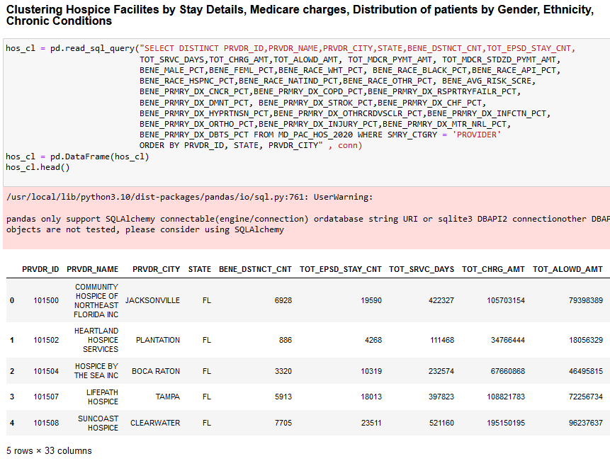

**Figure 71:** Data frame of 33 features for Hospice facilities for cluster analysis

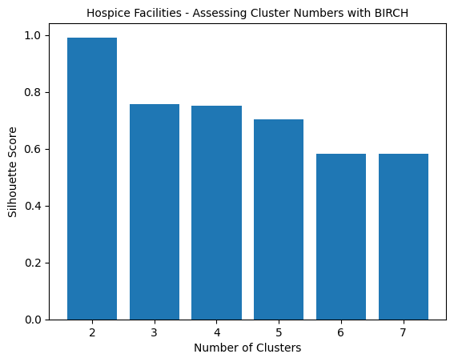

**Figure 72:** Visualizing clustering loop results in determining the best number of clusters to segregate Hospice facilities. N=2 gave the best results.

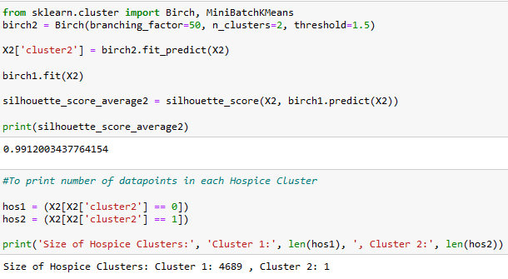

**Figure 73:** Clustering is redone with n=2 clusters for Hospice data with printed output of silhouette scores number of data points in each cluster after analysis.

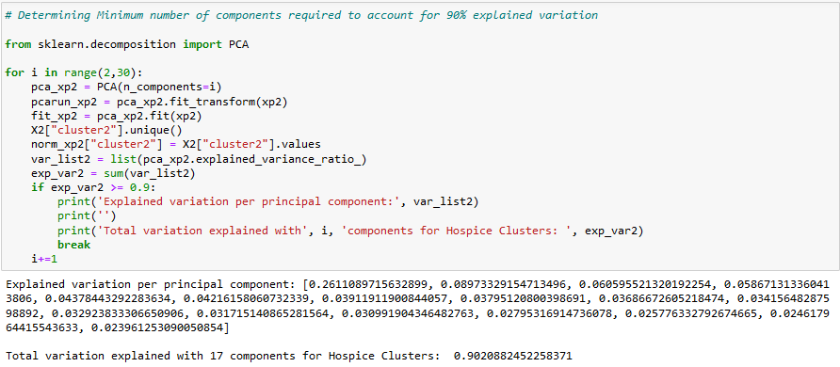

**Figure 74:** Looped PCA analysis showing a minimum of 17 components are required to account for 90% of explained variation in Hospice clusters.

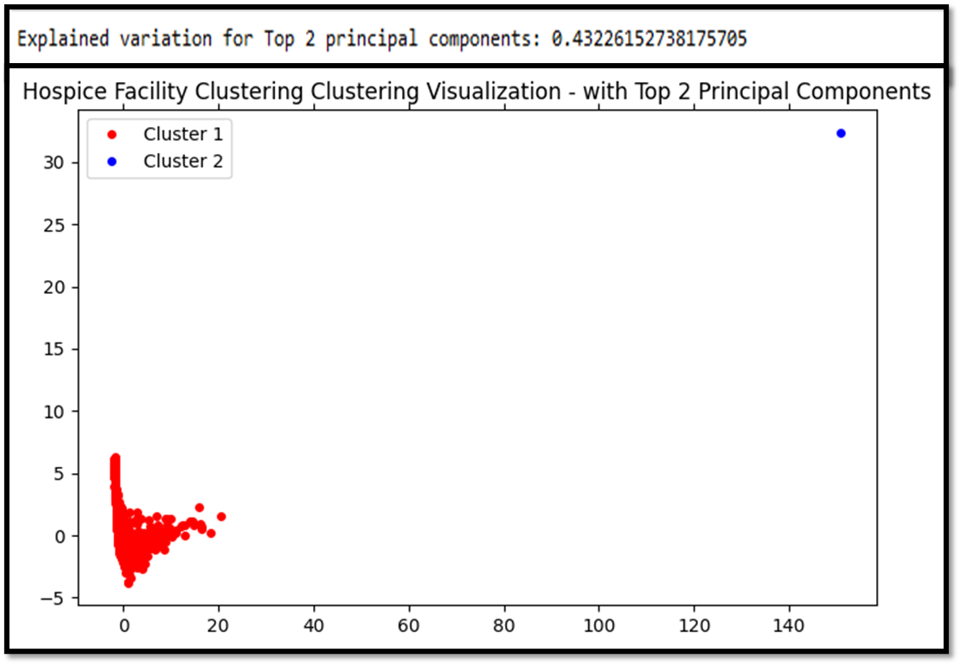

**Figure 75:** Scatter plot to visualize Hospice clusters using the top 2 principal components that account for the maximum amount of explained variation with printed output above the graph

The clustering and PCA analysis for Hospice facilities showed that even with significant variation in the top 2 principal components (26% and 8%), hospice facilities couldn’t be segregated into more than a single cluster. This is bolstered by the fact that the 2nd cluster only included 1 provider.

**RESULTS FOR HOME HEALTH FACILITIES**

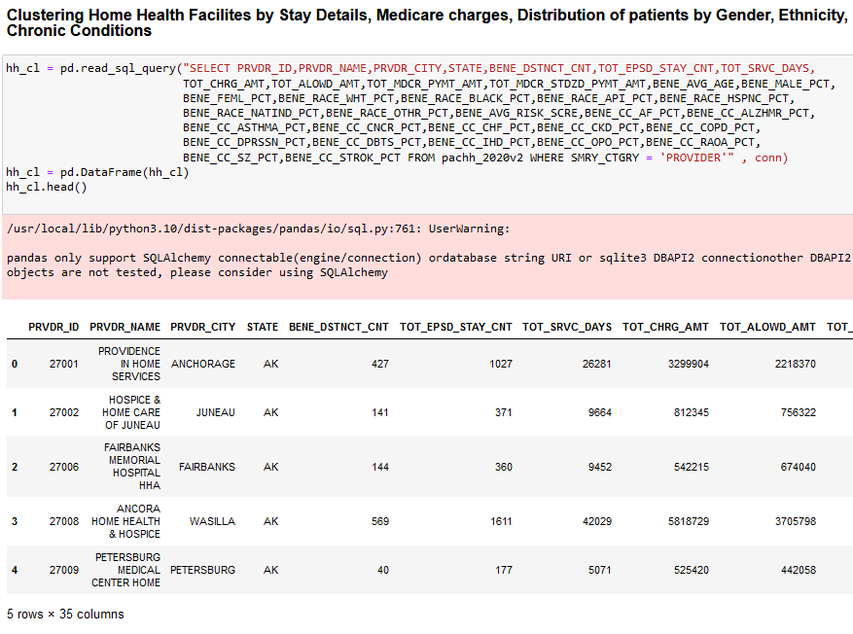

**Figure 76:** Data frame of 35 features for Home Health facilities for cluster analysis

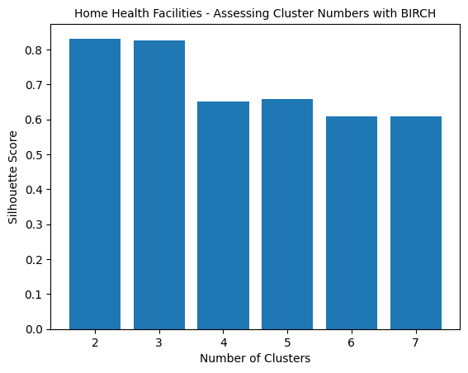

**Figure 77:** Visualizing clustering loop results to determine best number of clusters to segregate Home Health facilities. N=2 gave the best results.

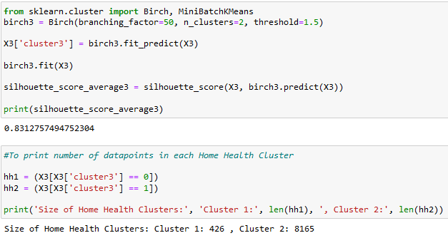

**Figure 78:** Clustering redone with n=2 clusters for Home Health data with printed output of silhouette scores number of data points in each cluster after analysis.

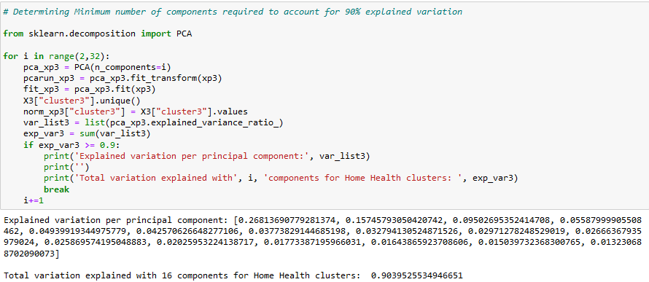

**Figure 79:** Looped PCA analysis of scaled Home Health facility features showing a minimum of 16 components are required to account for 90% of explained variation.

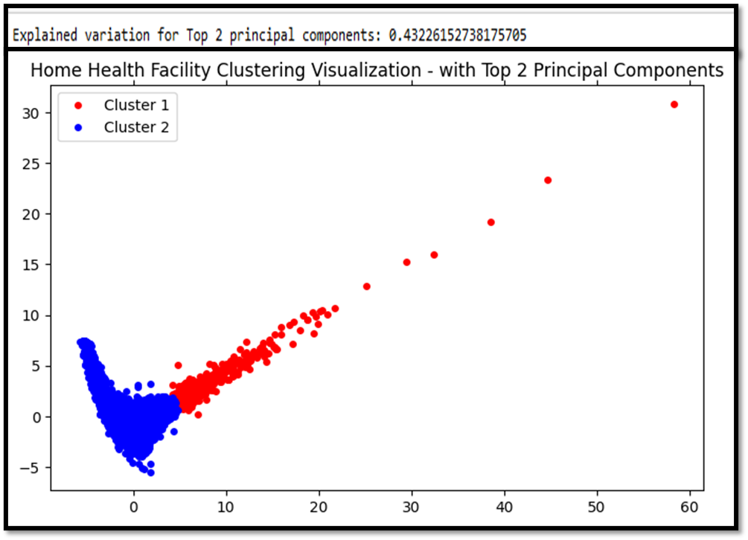

**Figure 80:** Scatter plot to visualize Home Health clusters using the top 2 principal components that account for the maximum amount of explained variation with printed output above the graph

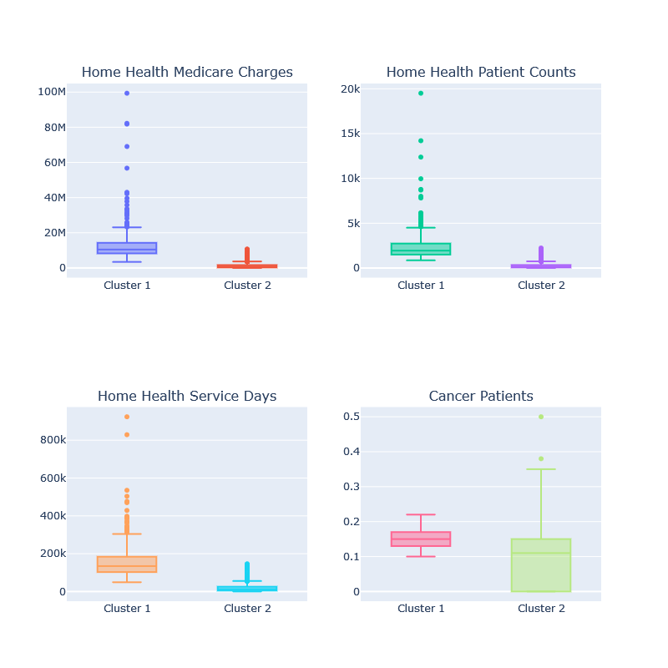

**Figure 81:** Grouped Boxplot to visualize distribution of datapoints for certain features in the individual Home Health clusters

The clustering and PCA analysis for Home Health agencies showed that variations in the features was sufficient to segregate these facilities into 2 clusters with some overlap, that showed differences in medicare charge, number of service days and patient counts.

**RESULTS FOR INPATIENT REHAB FACILITIES**

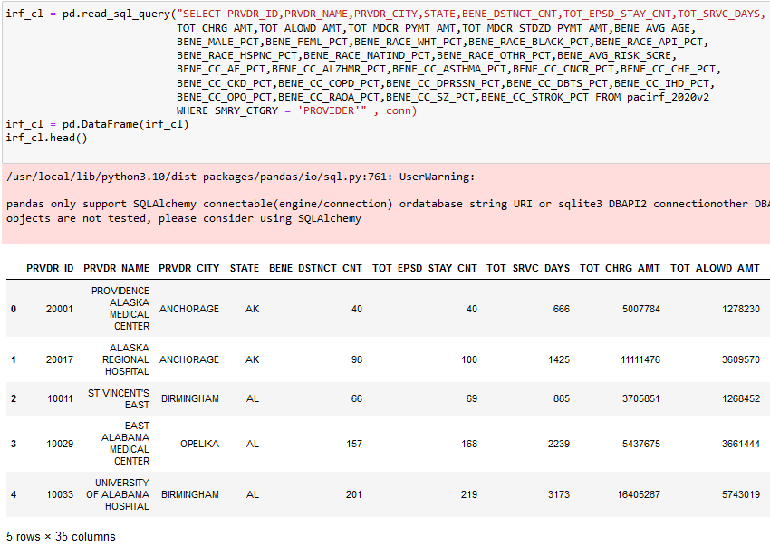

**Figure 82:** Data frame of 35 features for IRF facilities for cluster analysis

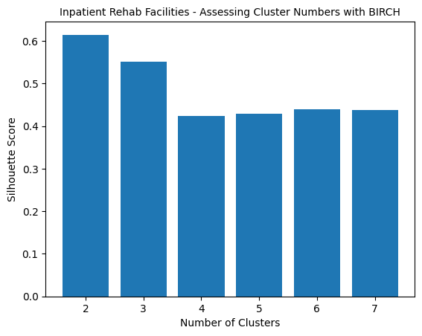

**Figure 83:** Visualizing clustering loop results to determine best number of clusters to segregate IRF facilities. N=2 gave the best results.

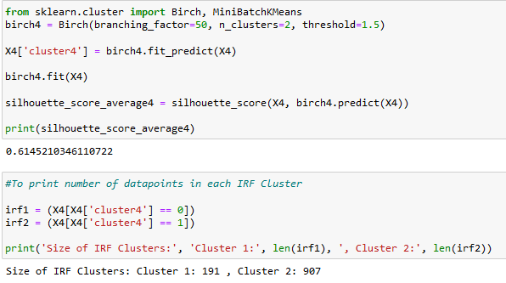

**Figure 84:** Clustering redone with n=2 clusters for IRF data with printed output of silhouette scores number of data points in each cluster after analysis.

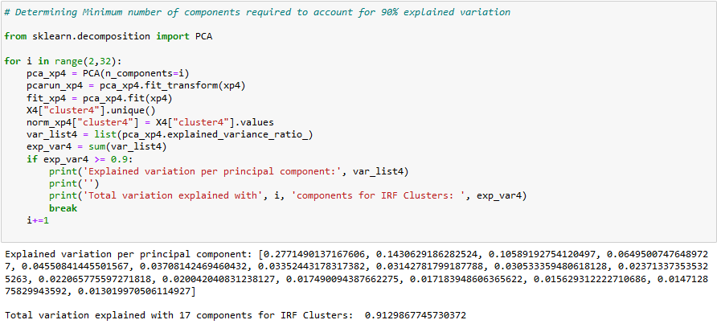

**Figure 85:** Looped PCA analysis of scaled IRF facility features showing a minimum of 17 components are required to account for 90% of explained variation.

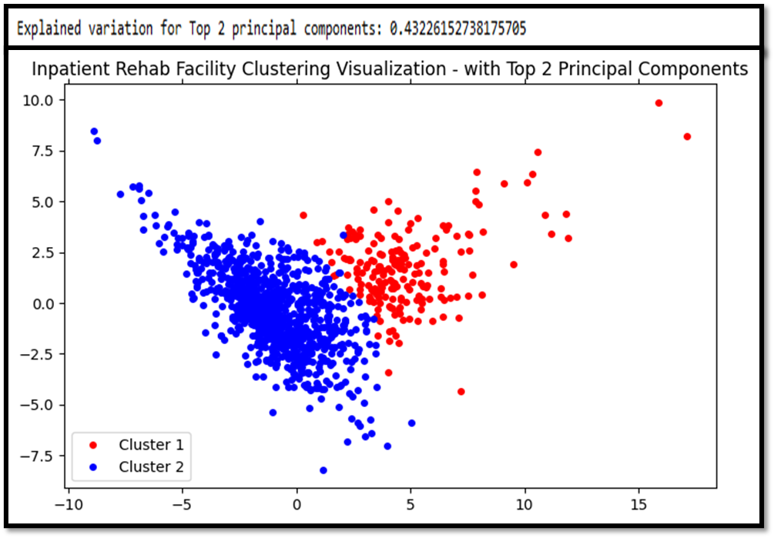

**Figure 86:** Scatter plot to visualize IRF clusters using the top 2 principal components that account for the maximum amount of explained variation with printed output above the graph

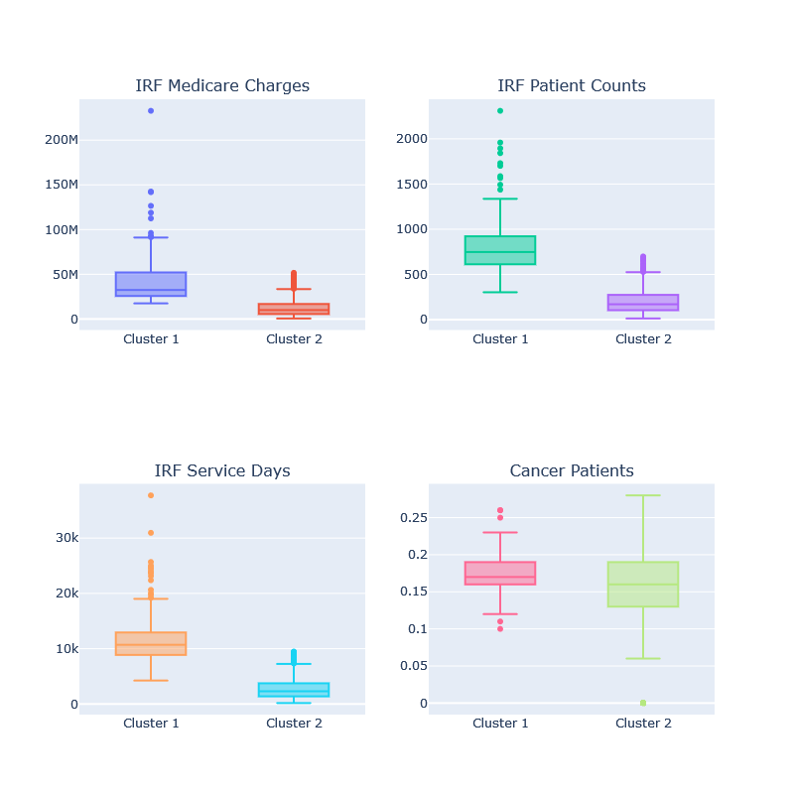

**Figure 87:** Grouped Boxplot to visualize distribution of datapoints for certain features in the individual IRF clusters

The clustering and PCA analysis for IRF facilities showed that variations in the features were sufficient to segregate these facilities into 2 clusters with some overlap, that showed differences in medicare charge, number of service days and patient counts.

**RESULTS FOR LONG TERM CARE FACILITIES**

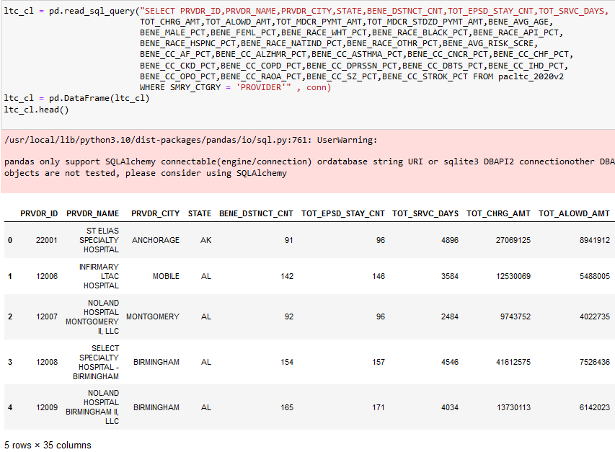

**Figure 88:** Data frame of 35 features for LTC facilities for cluster analysis

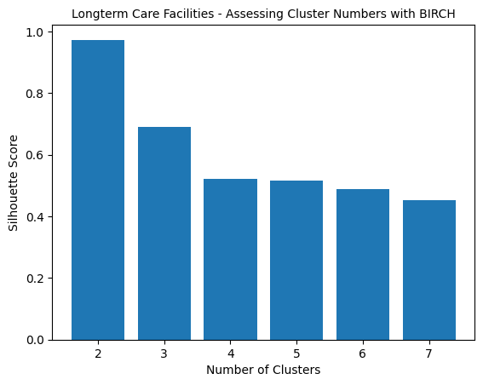

**Figure 89:** Visualizing clustering loop results to determine best number of clusters to segregate LTC facilities. N=2 gave the best results.

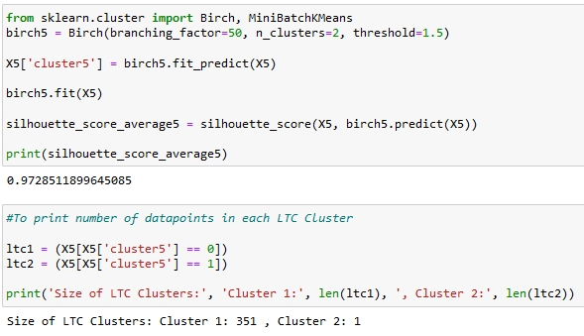

**Figure 90:** Clustering redone with n=2 clusters for LTC data with printed output of silhouette scores number of data points in each cluster after analysis.

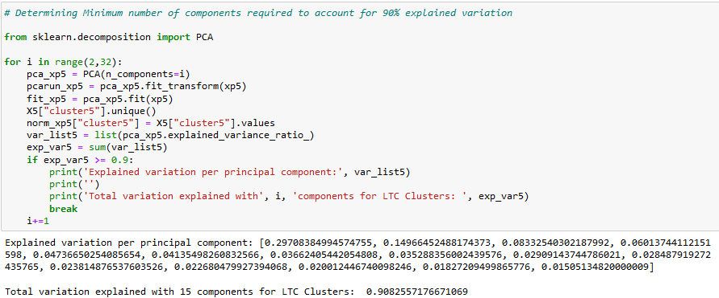

**Figure 91:** Looped PCA analysis of scaled LTC facility features showing a minimum of 15 components are required to account for 90% of explained variation.

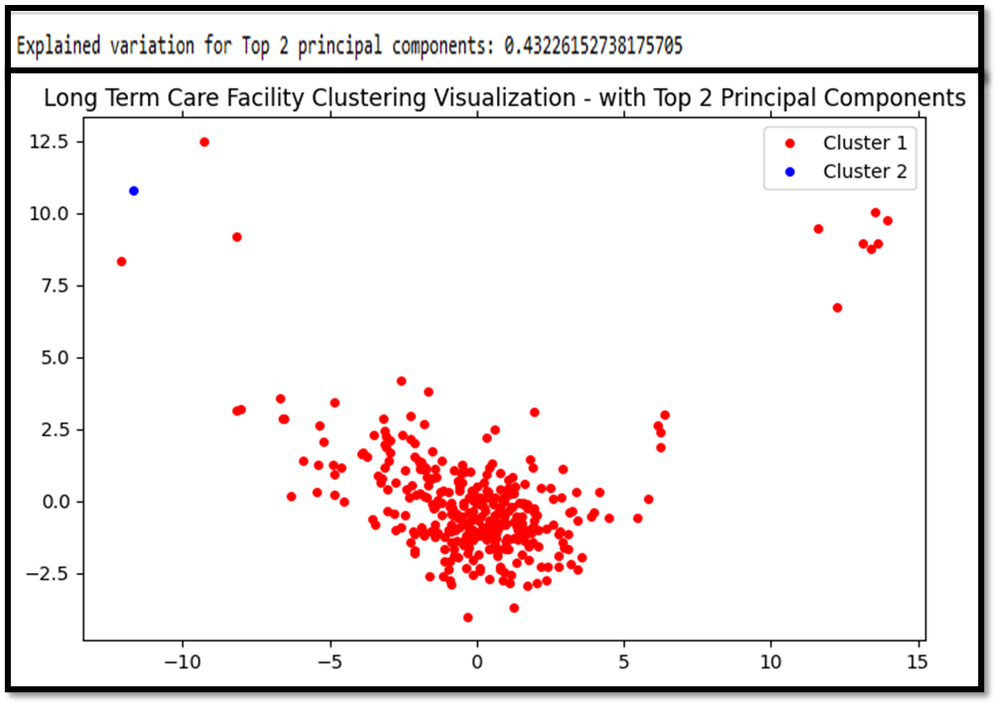

**Figure 92:** Scatter plot to visualize LTC clusters using the top 2 principal components that account for the maximum amount of explained variation with printed output above the graph

The clustering and PCA analysis for LTC facilities showed that even with significant variation in the top 2 principal components (30% and 14%), hospice facilities couldn’t be segregated into more than a single cluster. This is bolstered by the fact that the 2nd cluster only included 1 provider.

1. **Summary of Findings**
   1. **Research Question One:** Has there been a change in the inpatient and outpatient procedures patients access pre-pandemic (2018-2019) compared to during the pandemic (2020) which is discernable at various geographic levels (City, State)

**Findings:** From section 5.1.3 we can see that there was a discernible increase in inpatient hospitalizations in 2020 as compared to previous years, with a rise in patient counts seen across various several states.

While outpatient services showed an opposing trend with patient numbers decrease in 2020, this drop wasn’t nearly as steep as the increase in inpatient cases. Both trends can be attributed to the COVID 19 pandemic where inpatient hospitalizations for COVID related treatment and side effects increased while non-essential outpatient services that were considered less urgent were availed only in cases of emergency.

This proves our alternate hypothesis.

* 1. **Research Question Two:** What is the difference in cost for the most frequently used procedures across cities within a State or between neighboring states?

**Findings:** From Section 5.1.3 it is evident that there is a major difference in the cost of the same inpatient services being offered by different providers at the national and state levels. While a similar trend was once again seen with outpatient procedures, the cost difference was not nearly as pronounced since these procedures are generally not as expensive as inpatient procedures.

This proves our alternate hypothesis.

* 1. **Research Question Three:** Is there a disparity in the availability of inpatient and outpatient procedures across various geographic levels?

**Findings:** From Sections 5.1.1 and 5.1.2 it is evident that despite the states having the highest population counts also having the highest number of facilities in many cases, when this data is normalized with population data, it is clear that people living in lesser populated states have better access to facilities as compared to their counterparts.

This proves our alternate hypothesis.

* 1. **Research Question Four:** Can we use access to care parameters such as differences in gender, medicare costs, duration of services provided and patient episodes to segregate PAC and Hospice facilities into distinct clusters?

**Findings:** We answered this question with data from sections 5.1.4 and 5.1.5 and the clustering analysis.

Based on the trending analysis in sections 5.1.4 and 5.1.5, it is evident that PAC services are most frequently availed by 2 main demographics: Female and White patients.

Clustering analysis showed us that we could successfully only segregate 3 out of 5 types of PAC facilities into 2 clusters with distinct overlaps and some degree of overlap. These were the SNFs, Home Health and IRF facilities.

Clustering analysis yielded a silhouette score of between 0.69 to 0.83 for n=2 clusters, with an average of 15-17 features required to account for a variation of more than 90%.

In the case of the other two, even with a significant amount of variation in more than one principal component, the facilities couldn’t successfully be clustered. Clustering analysis yielded a silhouette score of between 0.97-0.99 for n=2 clusters, with an average of 15-17 features required to account for a variation of more than 90%.

While this trend goes against the alternate hypothesis, it is not an entirely surprising result since Hospice and Long terms care facilities cater to patients who are at the end of their life or are unable to live independently. As these limits the variety of services they need to provide their patients, it can be expected that these facilities would be standardized across the US and wouldn’t vary significantly enough to

Therefore, overall, we can conclude that the alternate hypothesis was true in this case since 3 out 5 types had distinct enough features that proves that there is indeed a difference in the services available to patients that can be attributed to geography, demography and facility characteristics.

1. **Limitations**

While analyzing the disparity in access to care at geographic levels, while we have normalized the numbers with population data, a deeper analysis into the raw data of the number of facilities per region shows that while the numbers support our conclusion, this difference might be emphasized since the total area coverage of a region has not been considered. This was beyond the scope of our current abilities but would provide a more meaningful context for our results.

Additionally, in our clustering analysis, while we performed PCA analysis to visualize our clustering results, we were unable to take this a step further and determine exactly which principal components gave the most variations for all datasets. While we have performed distribution analysis, to answer this question, this type of analysis is not ideal when working with unsupervised learning. We were also able to use only a single metric of the silhouette score to analyze the accuracy of our clustering method since our data didn’t have any actual labels. These parameters would’ve added more depth to our analysis.

1. **Appendix A – SQL Queries**

**Section I – SQL Queries for creating Tables for Data Analysis**

CREATE TABLE IHP_TOPDISCH_DISEASE_18 AS

(SELECT A.DRG_CD, A.DRG_DESC, SUM(A.TOT_DSCHRGS) AS TOT_DSCH_18

FROM Inpatient_2018_PrvSrv A

WHERE A.DRG_CD IN (871,291,470,177,193,872,189,378,392,690)

GROUP BY A.DRG_CD, A.DRG_DESC

ORDER BY SUM(A.TOT_DSCHRGS) DESC);

CREATE TABLE IHP_TOPDISCH_DISEASE_19 AS

(SELECT B.DRG_CD, B.DRG_DESC, SUM(B.TOT_DSCHRGS) AS TOT_DSCH_19

FROM Inpatient_2019_PrvSrv B

WHERE B.DRG_CD IN (871,291,470,177,193,872,189,378,392,690)

GROUP BY B.DRG_CD, B.DRG_DESC

ORDER BY SUM(B.TOT_DSCHRGS) DESC);

CREATE TABLE IHP_TOPDISCH_DISEASE_20 AS

(SELECT C.DRG_CD, C.DRG_DESC, SUM(C.TOT_DSCHRGS) AS TOT_DSCH_20

FROM Inpatient_2020_PrvSrv C

WHERE C.DRG_CD IN (871,291,470,177,193,872,189,378,392,690)

GROUP BY C.DRG_CD, C.DRG_DESC

ORDER BY SUM(C.TOT_DSCHRGS) DESC);

-----------------------------------------------------------------------------

CREATE TABLE IHP_TOPDISCH_STATE_18 AS

(SELECT A.Prv_State, SUM(A.TOT_DSCHRGS) AS TOT_DSCH_18

FROM Inpatient_2018_PrvSrv A

WHERE A.Prv_State IN ('FL','CA','TX','NY','IL','PA','OH','NC','MI','MA')

GROUP BY A.Prv_State

ORDER BY SUM(A.TOT_DSCHRGS) DESC);

CREATE TABLE IHP_TOPDISCH_STATE_19 AS

(SELECT B.Prv_State, SUM(B.TOT_DSCHRGS) AS TOT_DSCH_19

FROM Inpatient_2019_PrvSrv B

WHERE B.Prv_State IN ('FL','CA','TX','NY','IL','PA','OH','NC','MI','MA')

GROUP BY B.Prv_State

ORDER BY SUM(B.TOT_DSCHRGS) DESC);

CREATE TABLE IHP_TOPDISCH_STATE_20 AS

(SELECT C.Prv_State, SUM(C.TOT_DSCHRGS) AS TOT_DSCH_20

FROM Inpatient_2020_PrvSrv C

WHERE C.Prv_State IN ('FL','CA','TX','NY','IL','PA','OH','NC','MI','MA')

GROUP BY C.Prv_State

ORDER BY SUM(C.TOT_DSCHRGS) DESC);

----------------------------------------------------------------

CREATE TABLE OPD_TOPDISCH_DISEASE_18 AS

SELECT A.APC_Cd, A.APC_Desc, SUM(A.Bene_Cnt) AS TOT_DSCH_18

FROM Outpatient_2018_PrvSrv A

WHERE A.APC_Cd IN (8011,5072,5191,5115,5491,5114,5302,5361,5193,5373)

GROUP BY A.APC_Cd, A.APC_Desc

ORDER BY SUM(A.Bene_Cnt) DESC

CREATE TABLE OPD_TOPDISCH_DISEASE_19 AS

SELECT B.APC_Cd, B.APC_Desc, SUM(B.Bene_Cnt) AS TOT_DSCH_19

FROM Outpatient_2019_PrvSrv B

WHERE B.APC_Cd IN (8011,5072,5191,5115,5491,5114,5302,5361,5193,5373)

GROUP BY B.APC_Cd, B.APC_Desc

ORDER BY SUM(B.Bene_Cnt) DESC

CREATE TABLE OPD_TOPDISCH_DISEASE_20 AS

SELECT C.APC_Cd, C.APC_Desc, SUM(C.Bene_Cnt) AS TOT_DSCH_20

FROM Outpatient_2020_PrvSrv C

WHERE C.APC_Cd IN (8011,5072,5191,5115,5491,5114,5302,5361,5193,5373)

GROUP BY C.APC_Cd, C.APC_Desc

ORDER BY SUM(C.Bene_Cnt) DESC

--------------------------------------------------------------------------

CREATE TABLE OPD_TOPDISCH_STATE_18 AS

SELECT A.Prv_State, SUM(A.Bene_Cnt) AS TOT_DSCH_18

FROM Outpatient_2018_PrvSrv A

WHERE A.Prv_State IN ('CA','TX','FL','NY','IL','OH','PA','NC','MI','VA')

GROUP BY A.Prv_State

ORDER BY SUM(A.Bene_Cnt) DESC

CREATE TABLE OPD_TOPDISCH_STATE_19 AS

SELECT B.Prv_State, SUM(B.Bene_Cnt) AS TOT_DSCH_19

FROM Outpatient_2019_PrvSrv B

WHERE B.Prv_State IN ('CA','TX','FL','NY','IL','OH','PA','NC','MI','VA')

GROUP BY B.Prv_State

ORDER BY SUM(B.Bene_Cnt) DESC

CREATE TABLE OPD_TOPDISCH_STATE_20 AS

SELECT C.Prv_State, SUM(C.Bene_Cnt) AS TOT_DSCH_20

FROM Outpatient_2020_PrvSrv C

WHERE C.Prv_State IN ('CA','TX','FL','NY','IL','OH','PA','NC','MI','VA')

GROUP BY C.Prv_State

ORDER BY SUM(C.Bene_Cnt) DESC

**Section II – SQL Queries for Exploratory Data Analysis**

**SQL Queries for Inpatient Data Analysis before Table creation**

SELECT TOP 10 A.DRG_CD, A.DRG_DESC,

SUM(A.TOT_DSCHRGS) AS TOT_DSCH_DIS_18

FROM Inpatient_2018_PrvSrv A

GROUP BY A.DRG_CD, A.DRG_DESC

ORDER BY SUM(A.TOT_DSCHRGS) DESC

SELECT TOP 10 A.Prv_State,

SUM(A.TOT_DSCHRGS) AS TOT_DSCH_ST_18

FROM Inpatient_2018_PrvSrv A

GROUP BY A.Prv_State

ORDER BY SUM(A.TOT_DSCHRGS) DESC

SELECT TOP 10 A.DRG_CD, A.DRG_DESC,

SUM(A.TOT_DSCHRGS) AS TOT_DSCH_DIS_19

FROM Inpatient_2019_PrvSrv A

GROUP BY A.DRG_CD, A.DRG_DESC

ORDER BY SUM(A.TOT_DSCHRGS) DESC

SELECT TOP 10 A.Prv_State,

SUM(A.TOT_DSCHRGS) AS TOT_DSCH_ST_19

FROM Inpatient_2019_PrvSrv A

GROUP BY A.Prv_State

ORDER BY SUM(A.TOT_DSCHRGS) DESC

SELECT TOP 10 A.DRG_CD, A.DRG_DESC,

SUM(A.TOT_DSCHRGS) AS TOT_DSCH_DIS_20

FROM Inpatient_2020_PrvSrv A

GROUP BY A.DRG_CD, A.DRG_DESC

ORDER BY SUM(A.TOT_DSCHRGS) DESC

SELECT TOP 10 A.Prv_State,

SUM(A.TOT_DSCHRGS) AS TOT_DSCH_ST_20

FROM Inpatient_2020_PrvSrv A

GROUP BY A.Prv_State

ORDER BY SUM(A.TOT_DSCHRGS) DESC

**SQL Queries for Outpatient Data Analysis before Table creation**

SELECT TOP 11 A.APC_Cd, A.APC_Desc,

SUM(A.Bene_Cnt) AS TOT_DSCH_DIS_18

FROM Outpatient_2018_PrvSrv A

GROUP BY A.APC_Cd, A.APC_Desc

ORDER BY SUM(A.Bene_Cnt) DESC

SELECT TOP 10 A.Prv_State,

SUM(A.Bene_Cnt) AS TOT_DSCH_ST_18

FROM Outpatient_2018_PrvSrv A

GROUP BY A.Prv_State

ORDER BY SUM(A.Bene_Cnt) DESC

SELECT TOP 11 A.APC_Cd, A.APC_Desc,

SUM(A.Bene_Cnt) AS TOT_DSCH_DIS_19

FROM Outpatient_2019_PrvSrv A

GROUP BY A.APC_Cd, A.APC_Desc

ORDER BY SUM(A.Bene_Cnt) DESC

SELECT TOP 10 A.Prv_State,

SUM(A.Bene_Cnt) AS TOT_DSCH_ST_19

FROM Outpatient_2019_PrvSrv A

GROUP BY A.Prv_State

ORDER BY SUM(A.Bene_Cnt) DESC

SELECT TOP 11 A.APC_Cd, A.APC_Desc,

SUM(A.Bene_Cnt) AS TOT_DSCH_DIS_20

FROM Outpatient_2020_PrvSrv A

GROUP BY A.APC_Cd, A.APC_Desc

ORDER BY SUM(A.Bene_Cnt) DESC

SELECT TOP 10 A.Prv_State,

SUM(A.Bene_Cnt) AS TOT_DSCH_ST_20

FROM Outpatient_2020_PrvSrv A

GROUP BY A.Prv_State

ORDER BY SUM(A.Bene_Cnt) DESC

**Appendix B – Python scripts**

**Section I: Table creation and Data File upload Scripts**

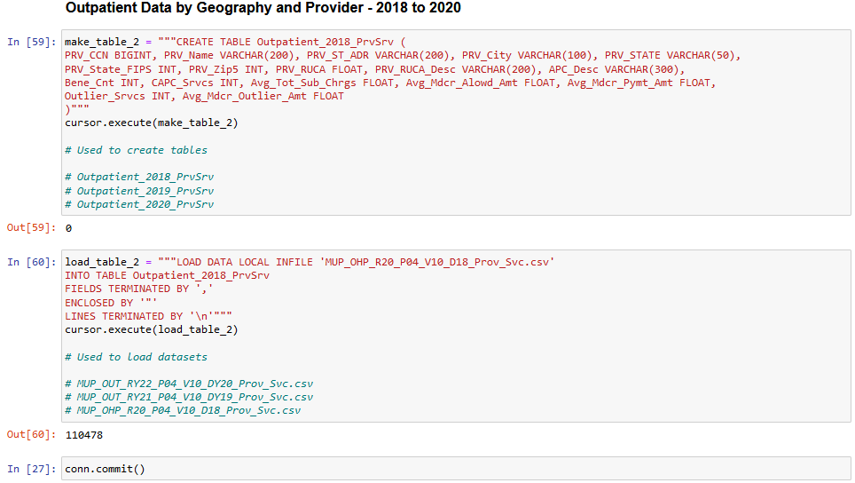

**Figure 93:** Table Creation and Data file upload script for importing the outpatient data files into the group database using Python Jupyter Notebook environment.

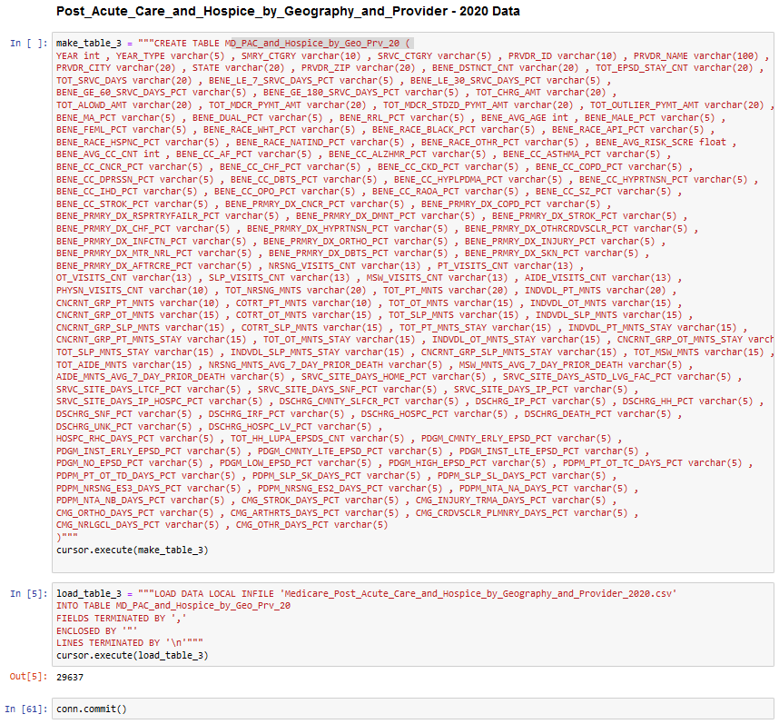

**Figure 94:** Table Creation and Data file upload script for importing the Post-Acute care and Hospice data master file into the group database using Python Jupyter Notebook environment.

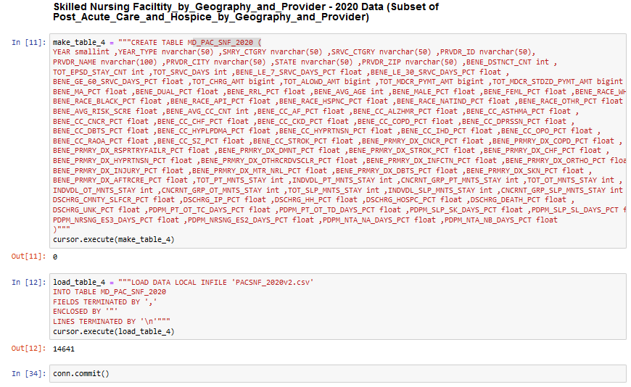

**Figure 95:** Table Creation and Data file upload script for importing the Skilled Nursing Facility sub-dataset file into the group database using Python Jupyter Notebook environment.

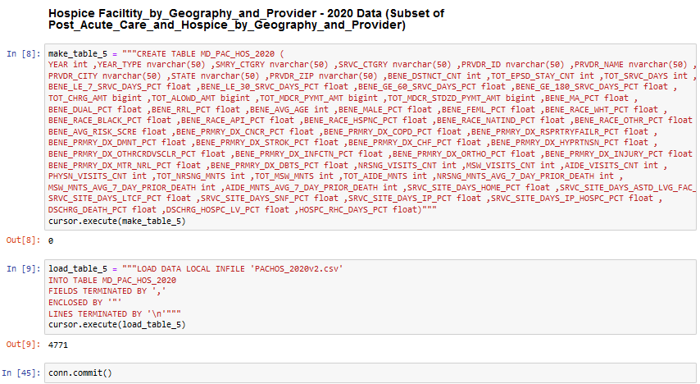

**Figure 96:** Table Creation and Data file upload script for importing the Hospice facility sub-dataset file into the group database using Python Jupyter Notebook environment.

**Section II: Code for Creating Choropleths to visualize number of facilities in different states across the US as Number of Facilities and with population normalization**

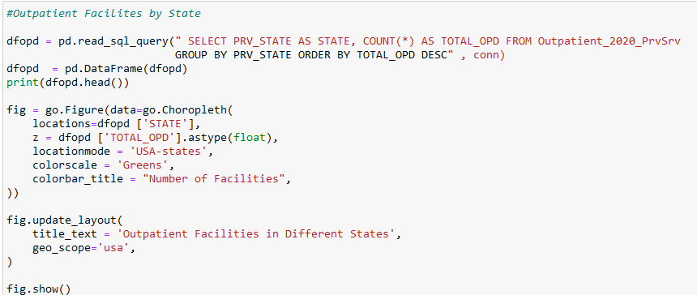

**Figure 97:** Code for visualizing Number of Outpatient Facilities per State on a Choropleth

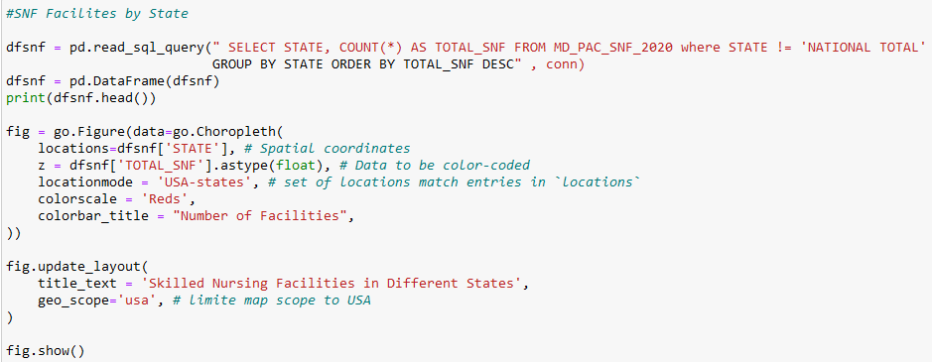

**Figure 98:** Code for visualizing Number of Skilled Nursing Facilities per State on a Choropleth

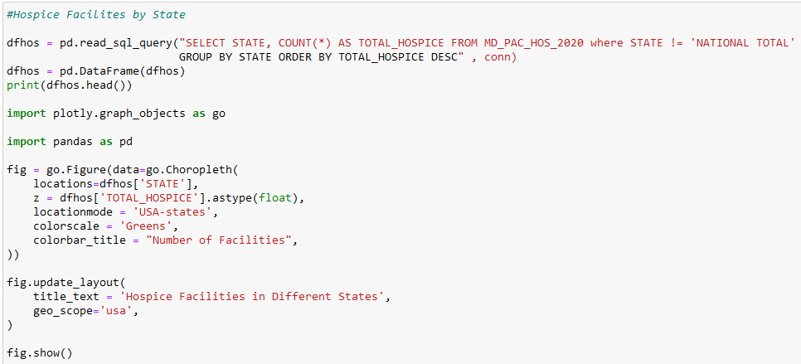

**Figure 99:** Code for visualizing Number of Hospice Facilities per State on a Choropleth

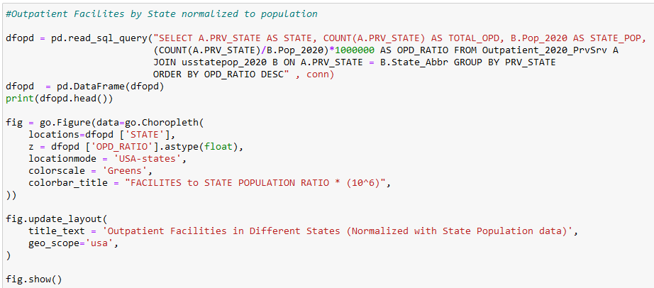

**Figure 100:** Code for visualizing Number of Outpatient Facilities per State normalized with population data on a Choropleth

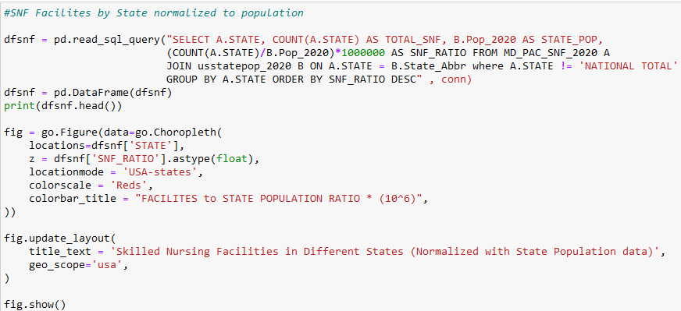

**Figure 101:** Code for visualizing Number of Skilled Nursing Facilities per State normalized with population data on a Choropleth

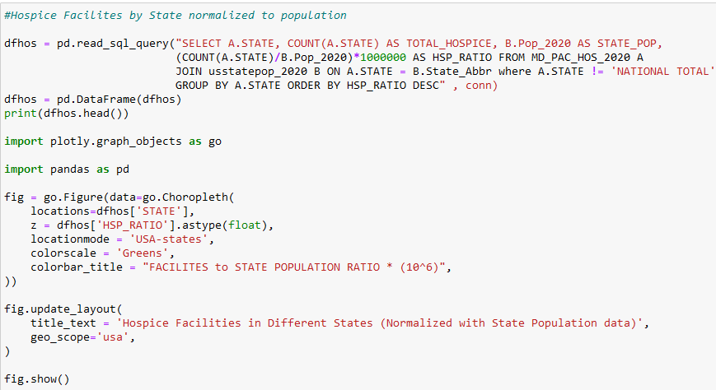

**Figure 102:** Code for visualizing Number of Hospice Facilities per State normalized with population data on a Choropleth

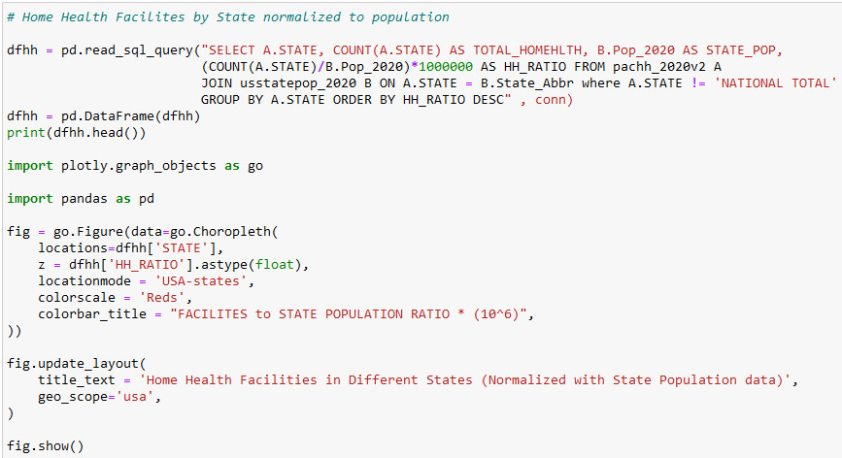

**Figure 103:** Code for visualizing Number of Home Health Facilities per State normalized with population data on a Choropleth

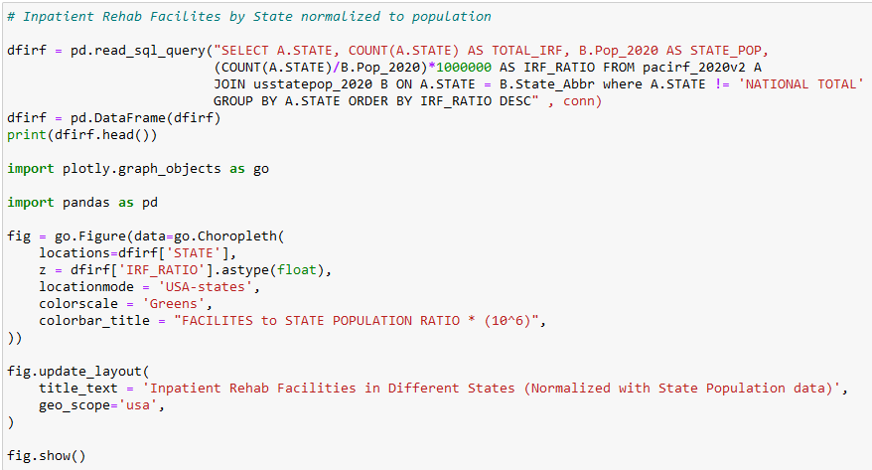

**Figure 104:** Code for visualizing Number of Inpatient Rehab Facilities per State normalized with population data on a Choropleth

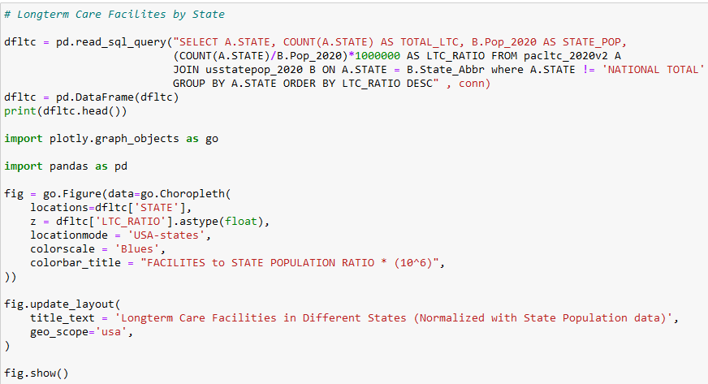

**Figure 105:** Code for visualizing Number of Long-Term Care Facilities per State normalized with population data on a Choropleth

**Section III: Code for Creating Bar Graphs to visualize number of facilities in different cities across Indiana State as Number of Facilities and with population normalization**

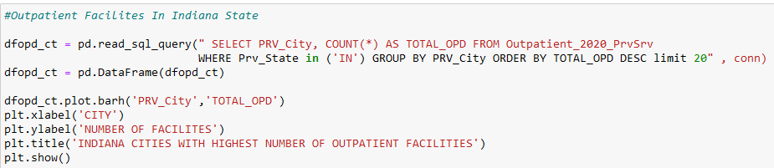

**Figure 106:** Code for visualizing Number of Outpatient Facilities per City in cities in Indiana State on a Horizontal Bar graph

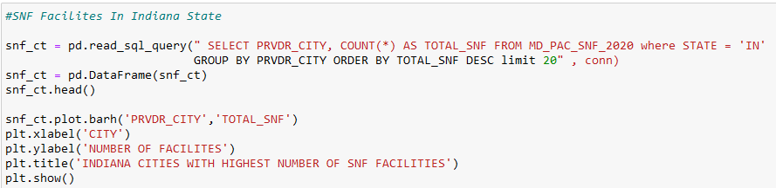

**Figure 107:** Code for visualizing Number of SNF Facilities per City in cities in Indiana State on a Horizontal Bar graph

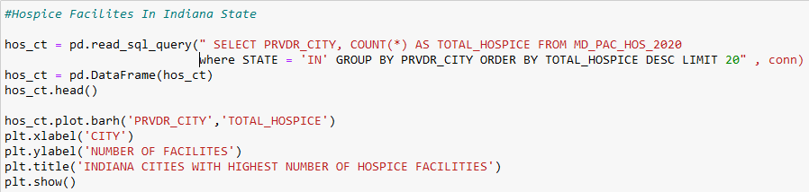

**Figure 108:** Code for visualizing Number of Hospice Facilities per City in cities in Indiana State on a Horizontal Bar graph

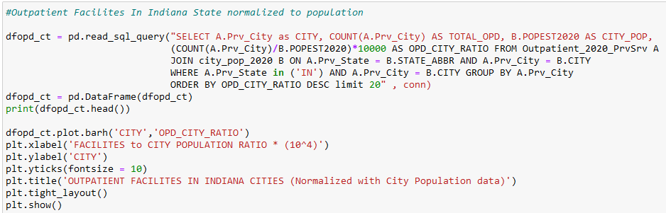

**Figure 109:** Code for visualizing Number of Outpatient Facilities per City in cities in Indiana State normalized to population data on a Horizontal Bar graph

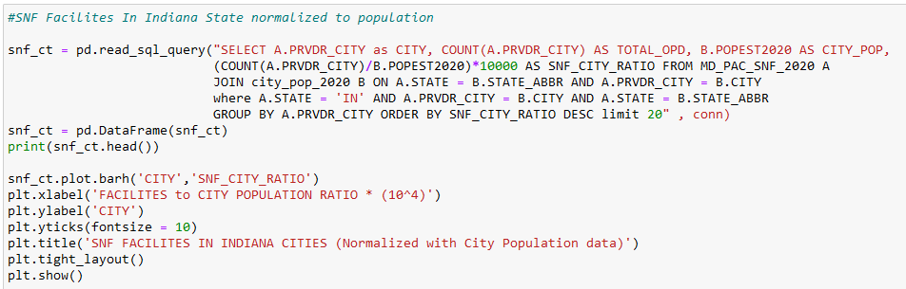

**Figure 110:** Code for visualizing Number of SNF Facilities per City in cities in Indiana State normalized to population data on a Horizontal Bar graph

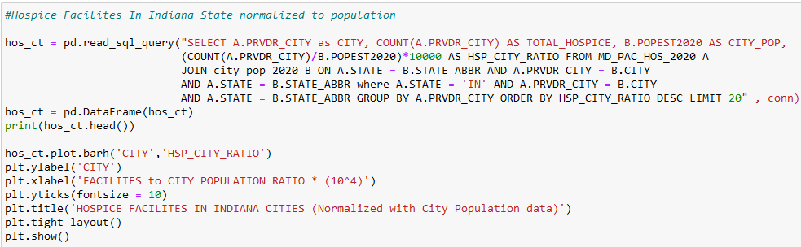

**Figure 111:** Code for visualizing Number of Hospice Facilities per City in cities in Indiana State normalized to population data on a Horizontal Bar graph

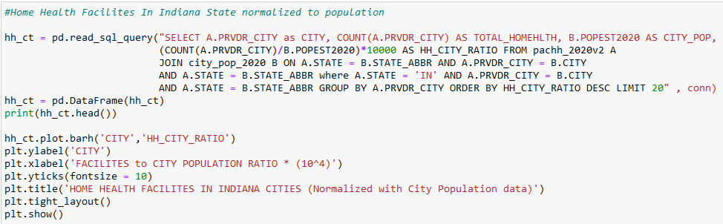

**Figure 112:** Code for visualizing Number of Home Health Facilities per City in cities in Indiana State normalized to population data on a Horizontal Bar graph

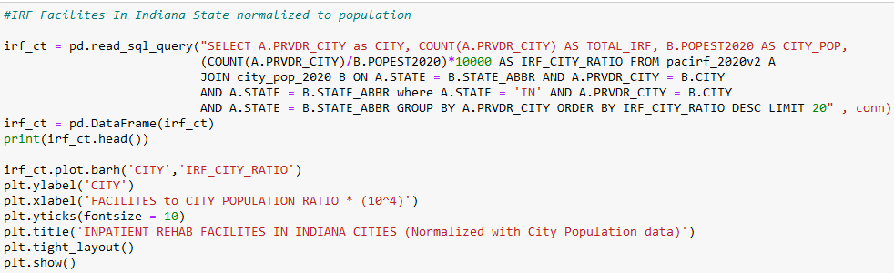

**Figure 113:** Code for visualizing Number of IRF Facilities per City in cities in Indiana State normalized to population data on a Horizontal Bar graph

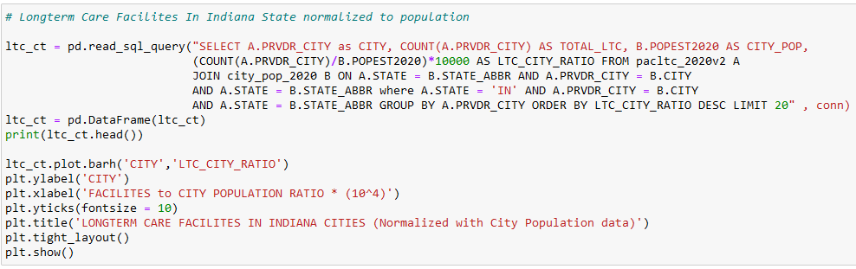

**Figure 114:** Code for visualizing Number of LTC Facilities per City in cities in Indiana State normalized to population data on a Horizontal Bar graph

**Section IV: Code for Visualizing Distribution of patients by gender**

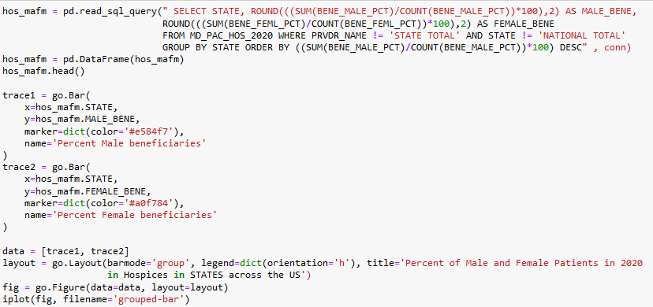

**Figure 115:** Code for assessing differences in access to Hospice facilities by gender at the state level, on a bar graph

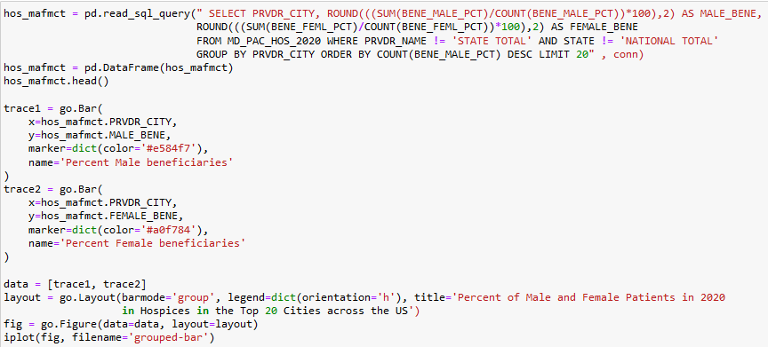

**Figure 116:** Code for assessing differences in access to Hospice facilities by gender in cities with the cities with the top 20 highest male patient counts, on a bar graph

**Section V: Code for Visualizing Distribution of patients by Ethnicity**

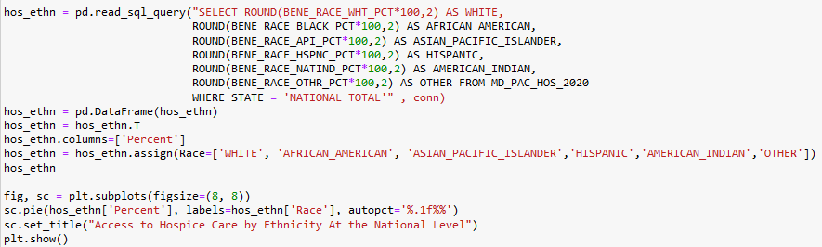

**Figure 117:** Code for assessing differences in access to Hospice facilities by ethnicity at the national level using a pie chart

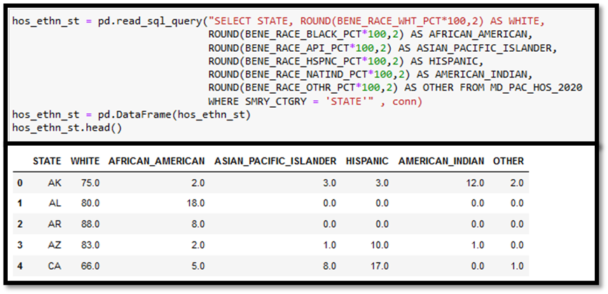

**Figure 118:** Code and partial output to assess differences in access to Hospice facilities by ethnicity in each state

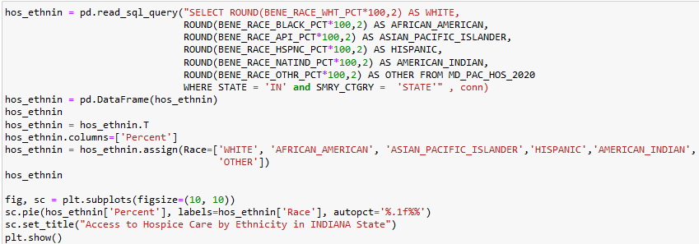

**Figure 119:** Code for assessing differences in access to Hospice facilities by ethnicity in the state of Indiana, using a pie chart

**Section VI: Code for Clustering and PCA analysis of PAC and Hospice facility subsets**

1. **Hospice Agencies**



**Figure 120:** Creating a data frame for 35 features for Hospice facilities for cluster analysis

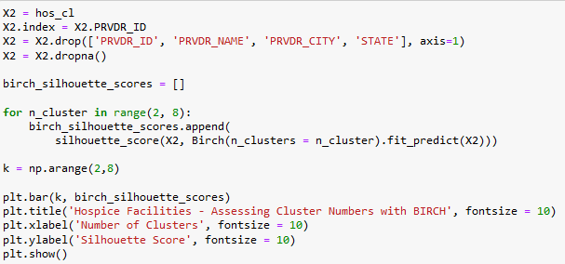

**Figure 121:** Dropping provider identifier details and running a loop to determine best number of clusters to segregate Hospice facilities

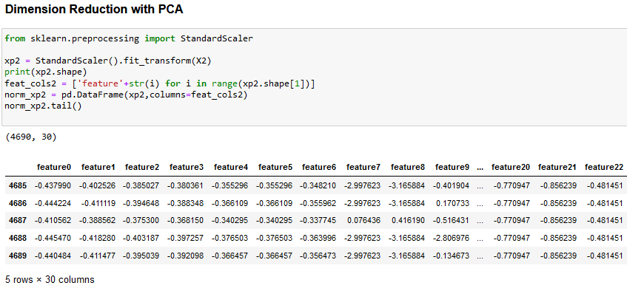

**Figure 122:** Standardized scalar transformation of Hospice features for PCA analysis.

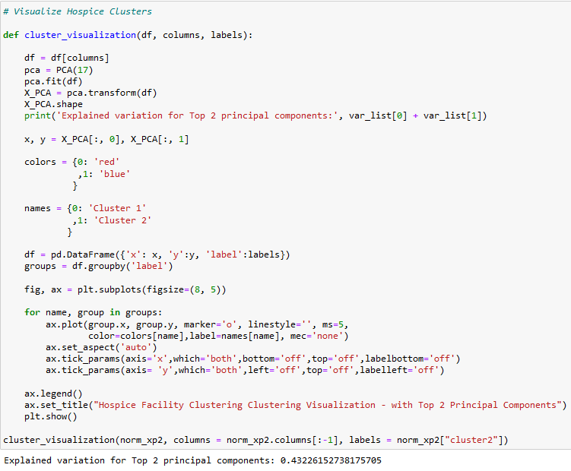

**Figure 123:** Code for visualizing Hospice clusters on a scatter plot using the top 2 principal components that account for the maximum amount of explained variation. The explained variation is printed in the output.

1. **Home Health Agencies**



**Figure 124:** Creating a data frame for 35 features for Home Health facilities for cluster analysis

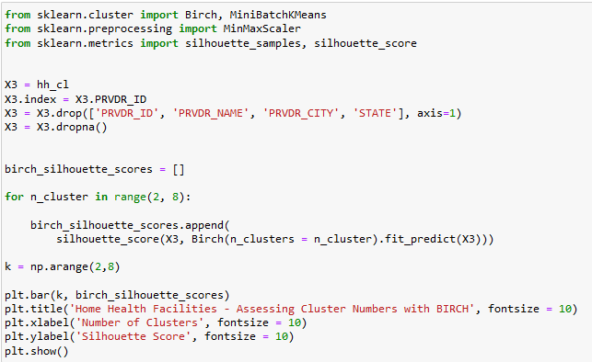

**Figure 125:** Dropping provider identifier details and running a loop to determine best number of clusters to segregate Home Health facilities

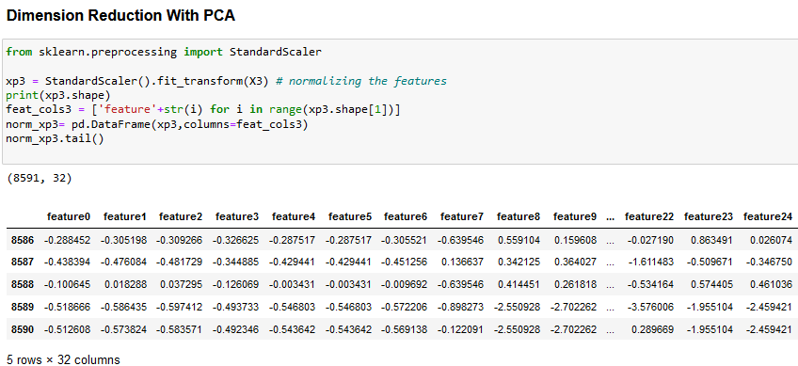

**Figure 126:** Standardized scalar transformation of Home Health features for PCA analysis.

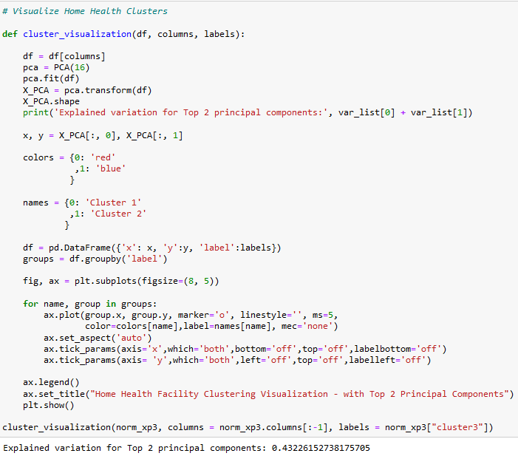

**Figure 127:** Code for visualizing Home Health clusters on a scatter plot using the top 2 principal components that account for the maximum amount of explained variation. The explained variation is printed in the output.

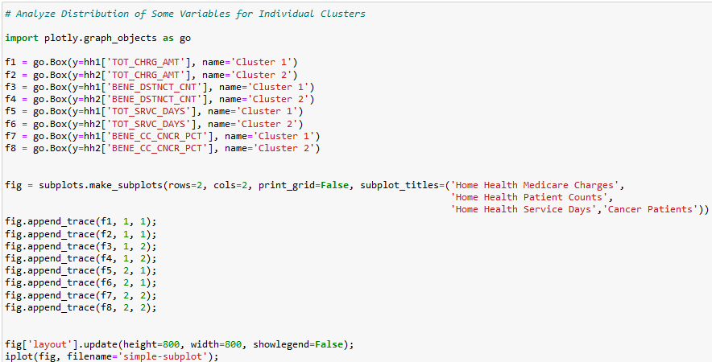

**Figure 128:** Code for grouped Boxplot to visualize distribution of datapoints for certain features in the individual Home Health clusters

1. **Inpatient Rehab Facilities**



**Figure 129:** Creating a data frame for 35 features for IRF facilities for cluster analysis

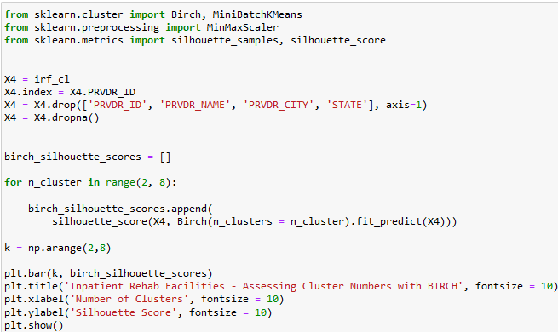

**Figure 130:** Dropping provider identifier details and running a loop to determine best number of clusters to segregate IRF facilities

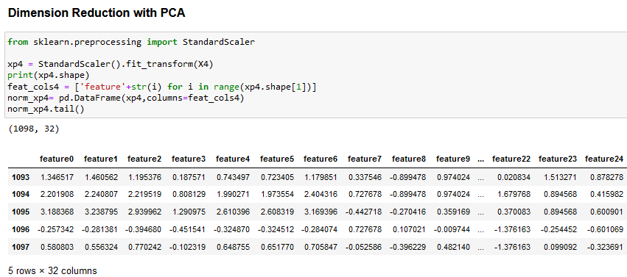

**Figure 131:** Standardized scalar transformation of IRF features for PCA analysis.

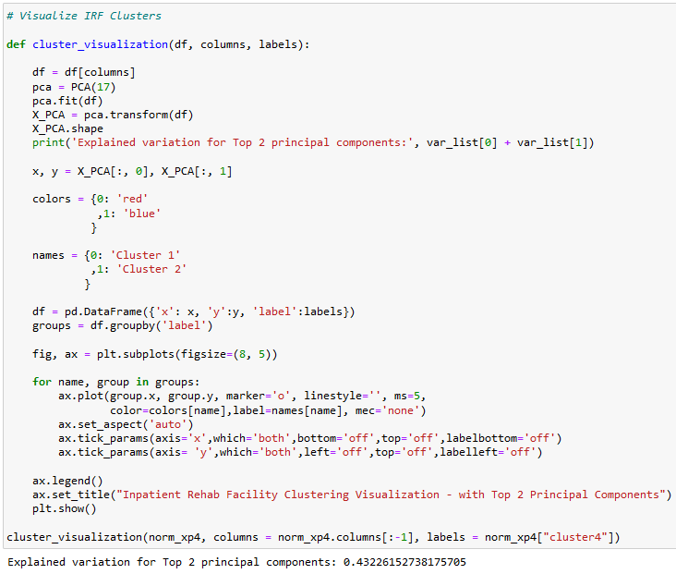

**Figure 132:** Code for visualizing IRF clusters on a scatter plot using the top 2 principal components that account for the maximum amount of explained variation. The explained variation is printed in the output.

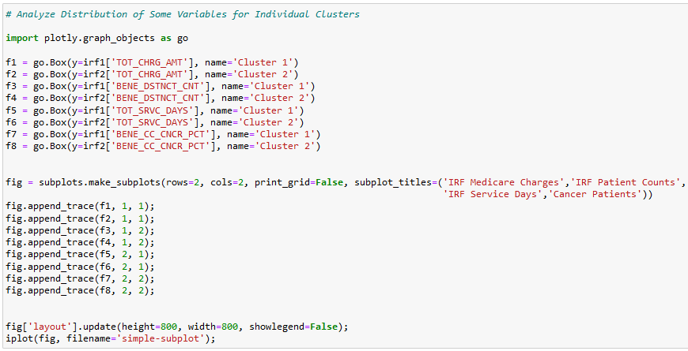

**Figure 133:** Code for grouped Boxplot to visualize distribution of datapoints for certain features in the individual IRF clusters

1. **Long Term Care Facilities**



**Figure 134:** Creating a data frame for 35 features for LTC facilities for cluster analysis

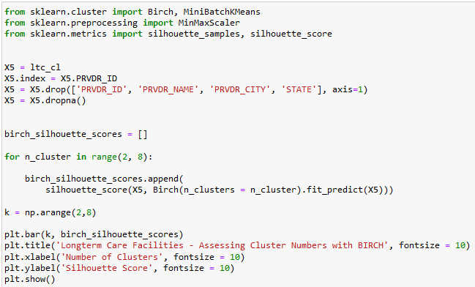

**Figure 135:** Dropping provider identifier details and running a loop to determine best number of clusters to segregate LTC facilities

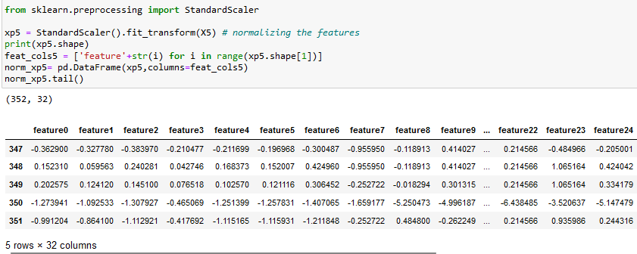

**Figure 136:** Standardized scalar transformation of LTC features for PCA analysis.

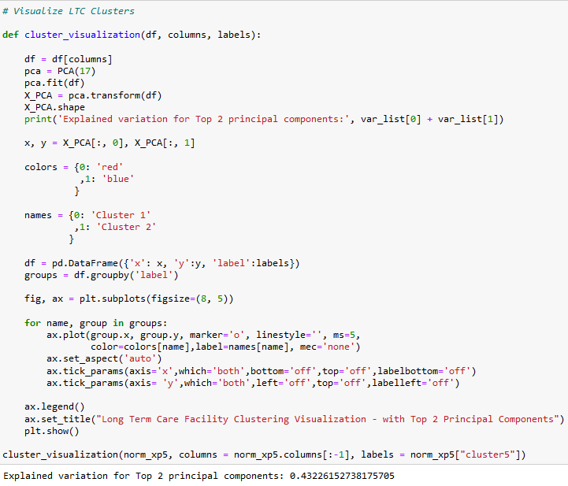

**Figure 137:** Code for visualizing LTC clusters on a scatter plot using the top 2 principal components that account for the maximum amount of explained variation. The explained variation is printed in the output.

**References**

1. Mues, K. E., Liede, A., Liu, J., Wetmore, J. B., Zaha, R., Bradbury, B. D., Collins, A. J., & Gilbertson, D. T. (2017). Use of the Medicare database in epidemiologic and health services research: a valuable source of real-world evidence on the older and disabled populations in the US. *Clinical epidemiology*, *9*, 267–277. <https://doi.org/10.2147/CLEP.S105613>
2. Hoffman, G. J., & Yakusheva, O. (2020). Association Between Financial Incentives in Medicare's Hospital Readmissions Reduction Program and Hospital Readmission Performance. *JAMA network open*, *3*(4), e202044. <https://doi.org/10.1001/jamanetworkopen.2020.2044>
3. Reid, R. O., Mafi, J. N., Baseman, L. H., Fendrick, A. M., & Damberg, C. L. (2021). Waste in the Medicare Program: a National Cross-Sectional Analysis of 2017 Low-Value Service Use and Spending. *Journal of general internal medicine*, *36*(8), 2478–2482. <https://doi.org/10.1007/s11606-020-06061-0>
4. Medicare Basics - https://www.medicare.gov/basics/get-started-with-medicare/medicare-basics/parts-of-medicare
5. Skilled Nursing Facilities - <https://www.investopedia.com/terms/s/skilled-nursing-facility.asp#:~:text=A%20skilled%20nursing%20facility%20is%20an%20in-patient%20rehabilitation,physical%20and%20occupational%20therapists%2C%20speech%20pathologists%2C%20and%20audiologists>.
6. Home Health coverage - <https://www.medicare.gov/what-medicare-covers/whats-home-health-care#:~:text=Home%20health%20care%20is%20a,skilled%20nursing%20facility%20(SNF)>
7. Hospice care - <https://www.nia.nih.gov/health/what-are-palliative-care-and-hospice-care#hospice>
8. Inpatient Rehabilitation Facilites - <https://www.bacharach.org/what-is-an-irf/>
9. Long term care facilities - <https://www.cdc.gov/longtermcare/index.html>
10. MacKay, E. J., Stubna, M. D., Chivers, C., Draugelis, M. E., Hanson, W. J., Desai, N. D., & Groeneveld, P. W. (2021). Application of machine learning approaches to administrative claims data to predict clinical outcomes in medical and surgical patient populations. PloS one, 16(6), e0252585. <https://doi.org/10.1371/journal.pone.0252585>
11. Wingrove, P., Liaw, W., Weiss, J., Petterson, S., Maier, J., & Bazemore, A. (2020). Using Machine Learning to Predict Primary Care and Advance Workforce Research. Annals of family medicine, 18(4), 334–340. https://doi.org/10.1370/afm.2550